TASKS ON VPC (Virtual Private Cloud)

1.Create VPC with 2 private and 2 public subnets.
OBJECTIVE: The main objective is to build a secure, scalable and highly available network architecture in AWS.

OUTCOME: This task will create a vpc and to that vpc will create 2 public subnets and 2 private subnets.

SUBNET: A subnetis a logical subdivision of an IP network.

PUBLIC SUBNET: A public subnet is a segment of a virtual network that has a direct route to an external internet Gateway.

PRIVATE SUBNET: Private subnets are isolated network segments within a cloud environment (like AWS, Azure or GCP) that do not have direct routing to the public internet.

STEP BY STEP IMPLEMENTATION:
- First of all, login into aws console.
- Then select the vpc service.
- Then click on create vpc.
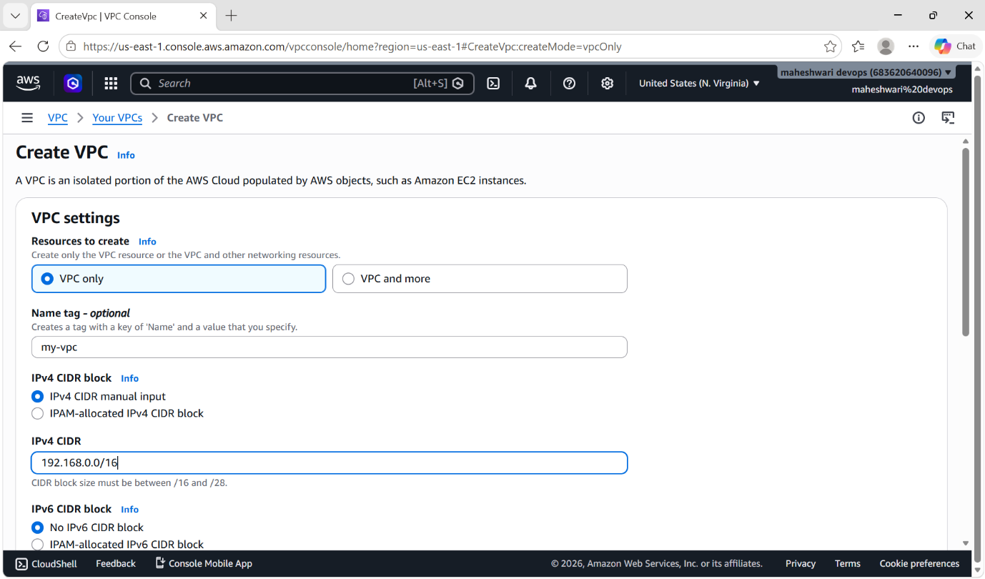
- Select vpc only option and assign a name tag for our vpc.
- Then will have to select IPV4 CIDR block out of two options, we have to select IPv4 CIDR manual input.
- Click on create vpc and our vpc will be created.

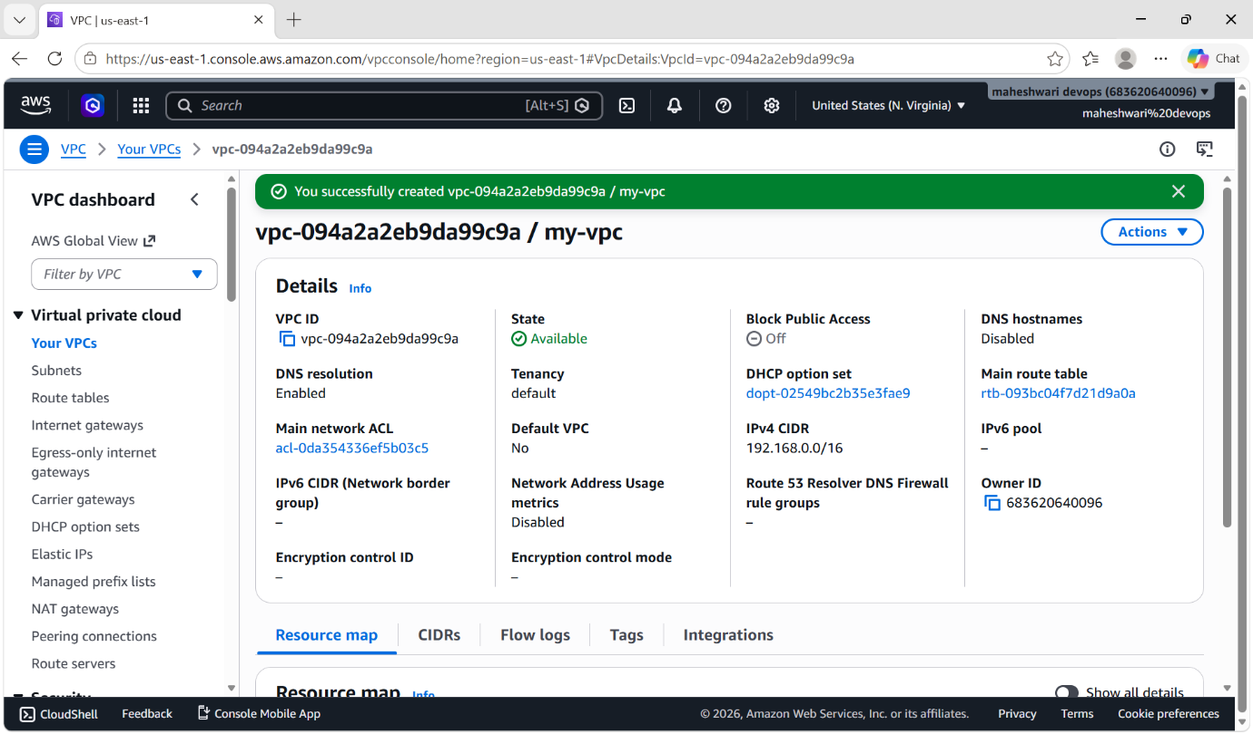

- Create 2 public subnets
- Below the vpc service only will have subnet option.
- Click on that subnet option and click on create a subnet.
- Then select to which vpc u want to create subnets.
- Create 2 public subnets with the names pub-subnet1 and pub-subnet2
- Set IPv4 CIDR range to both subnets and that CIDR range of subnets should not go beyond of our vpc CIDR range.
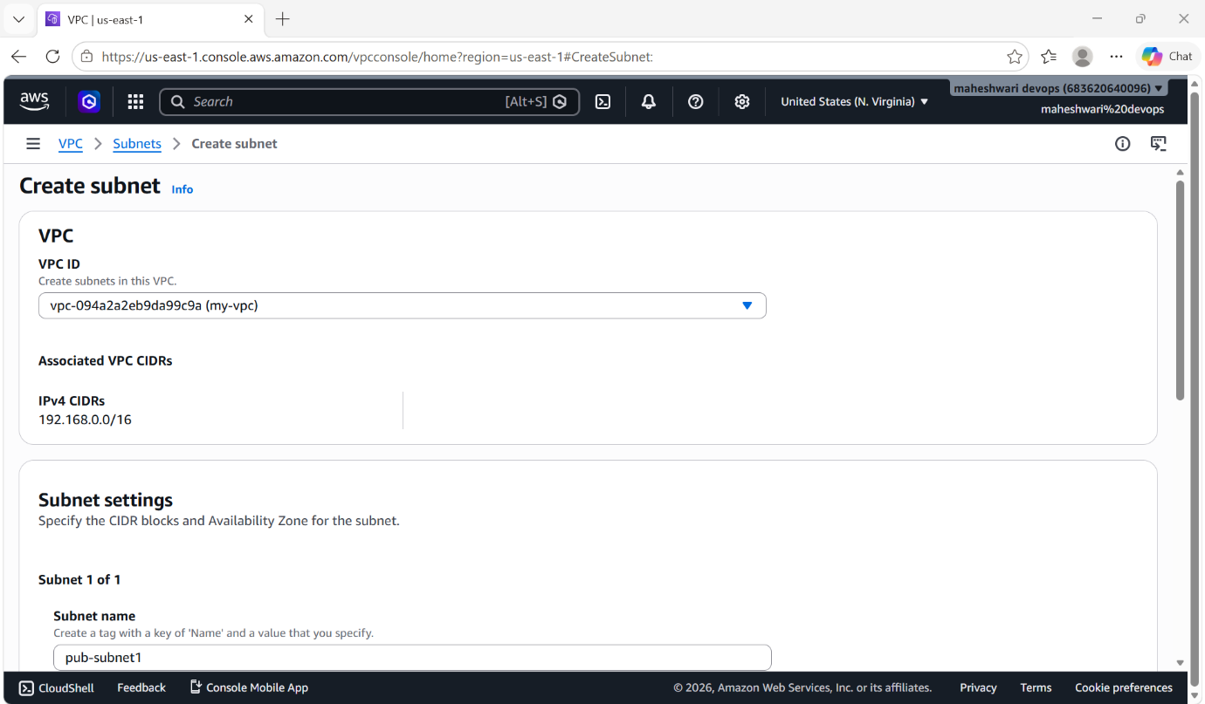

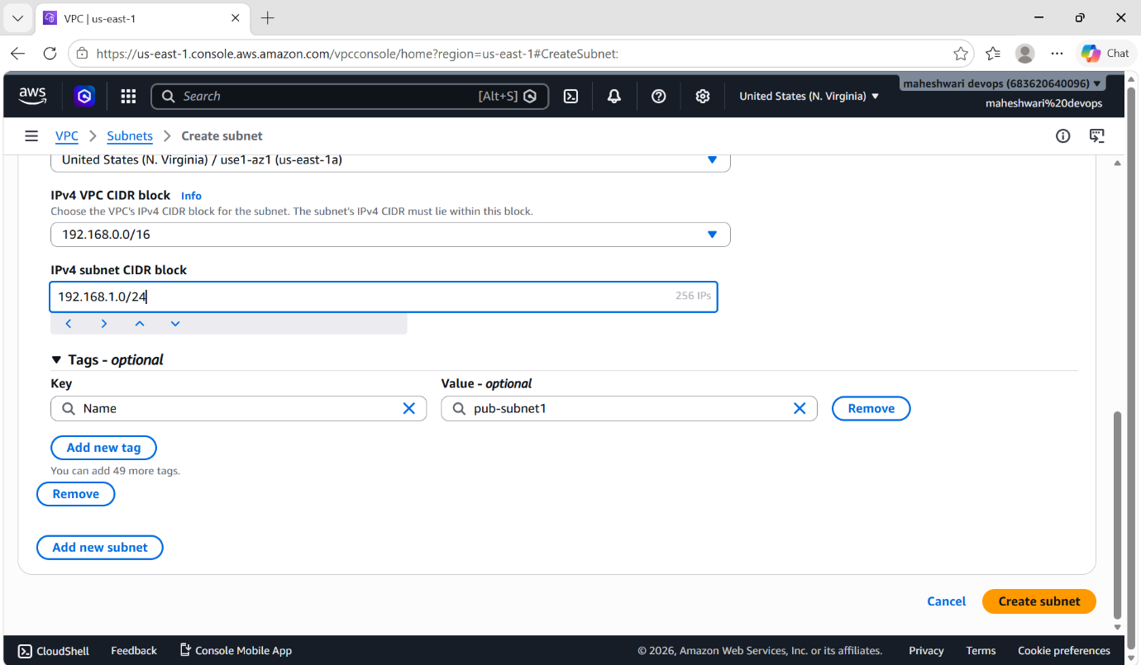
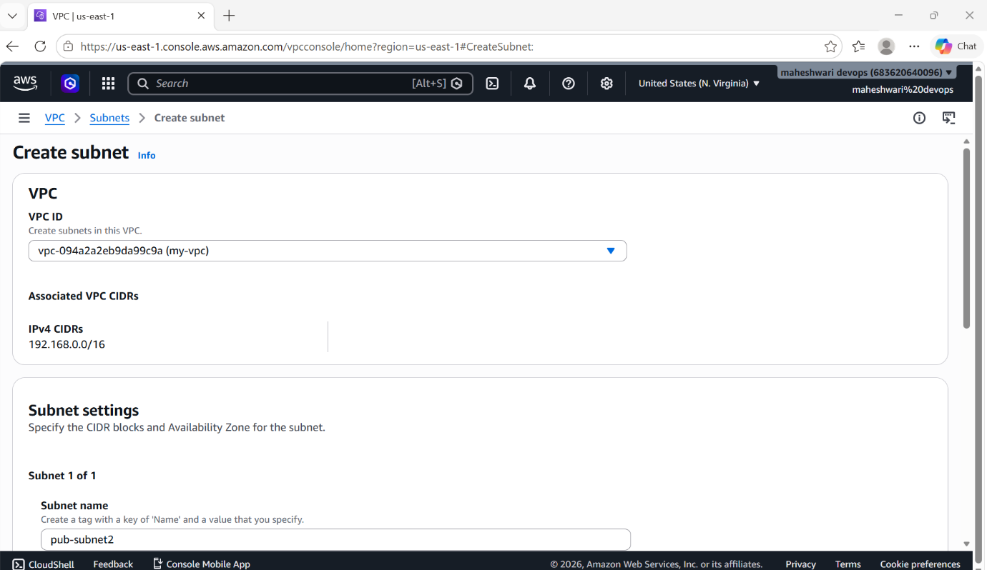

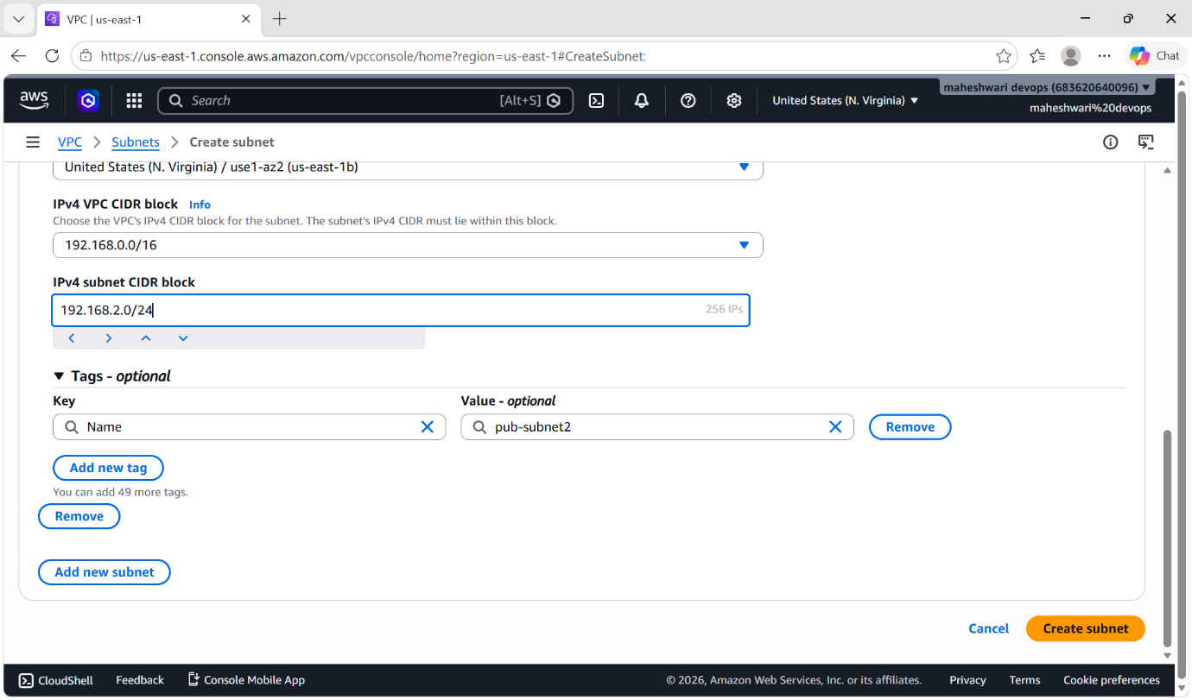
- Create 2 private subnets
- Click on that subnet option and click on create a subnet.
- Then select to which vpc u want to create subnets.
- Create 2 public subnets with the names pub-subnet1 and pub-subnet2
- Set IPv4 CIDR range to both subnets and that CIDR range of subnets should not go beyond of our vpc CIDR range.

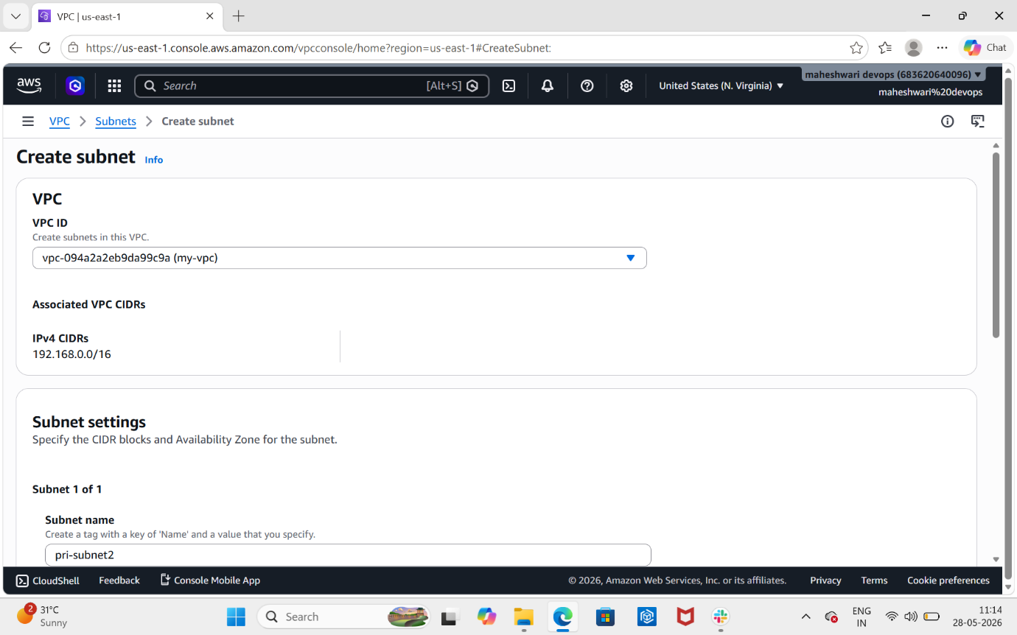

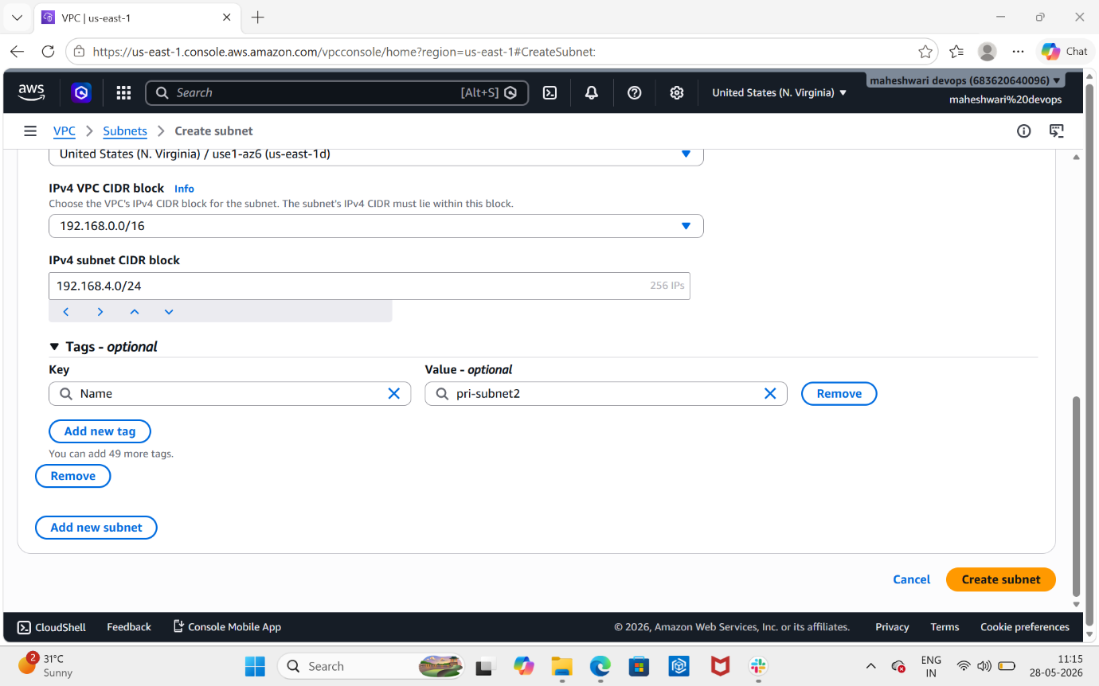

2. Enable DNS Hostname in VPC.
PURPOSE: Enabling DNS hostnames in a vpc ensures that instances launched with public ip addresses receive corresponding public DNS hostnames (in the format ://amazonaws.com).

OBJECTIVE: This simplifies resource access, as it allows machines to map and connect using human-readable names instead of raw IP addresses.

OUTCOME: Enabling DNS hostnames in a VPC ensures that EC2 instances launched within that network are automatically assigned distinct domain names.

STEP BY STEP IMPLEMENTATION:

- Login into aws console and go to VPC service.
- Then select the Vpc that u want to change the settings.
- Then drop down the actions block and it will show some options.
- Select edit vpc settings and it will show some information.
- In that page it will enable DNS hostnames option
- Tick that box and it will enable DNS hostname.
- Then click on save and it will save all the changes.

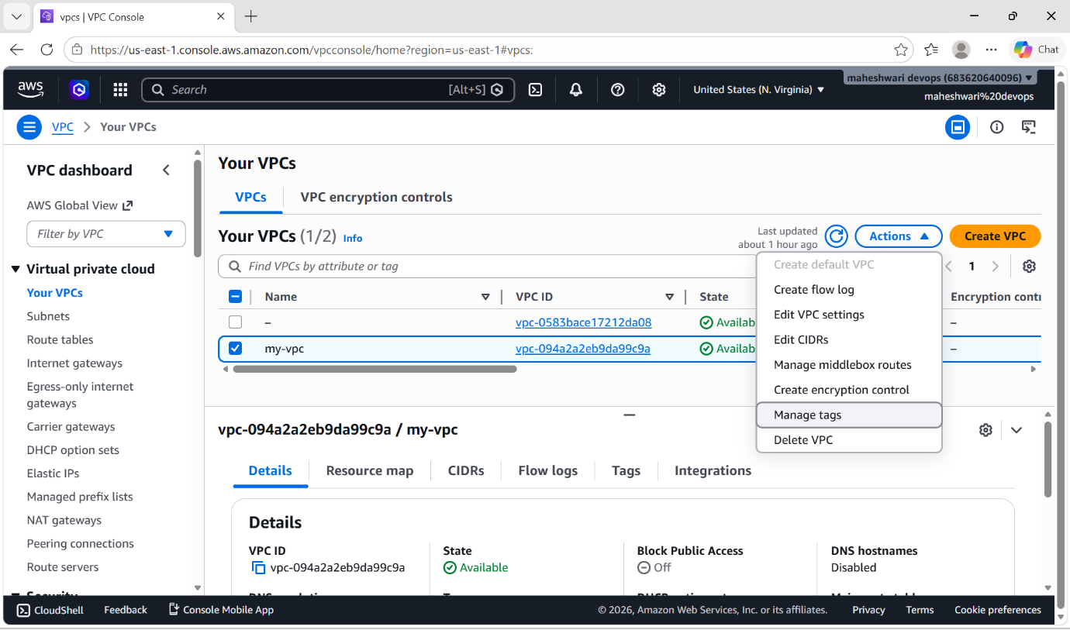

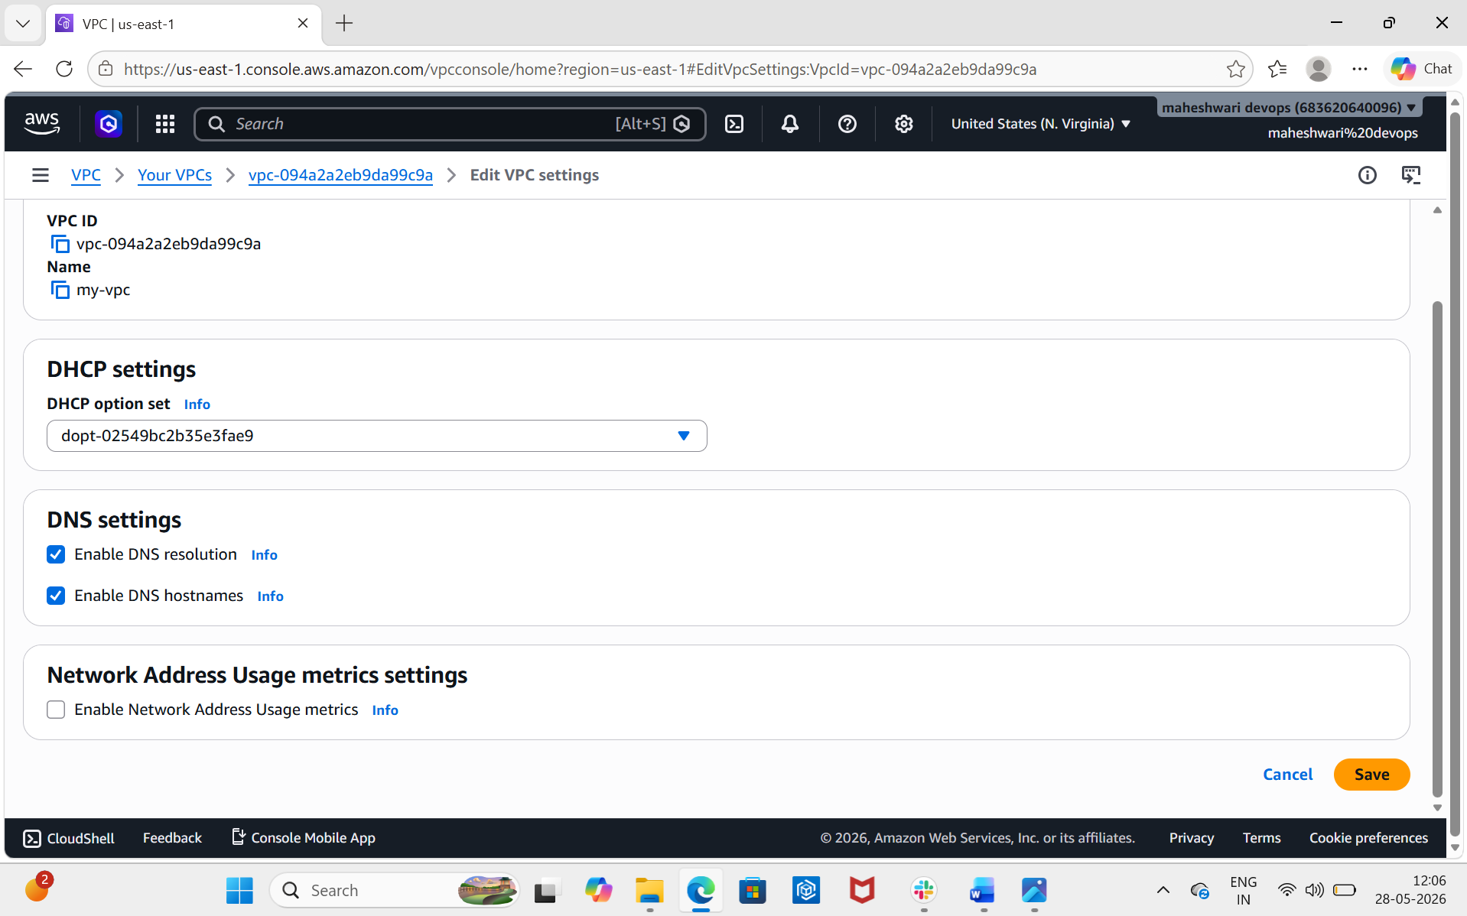

3. Enable Auto Assign Public IP in 2 public subnets.

PURPOSE: The primary purpose of enabling “Auto assign public IP” in public subnets is to automatically provide instances with an accessible IPv4 address at launch.

OBJECTIVE: The primary objective of enabling autop-assign public IP is to automatically expose instances to the internet.

OUTCOME: Enabling “Auto-assign Public IP” in a public subnet ensures that all instances (like ec2) and network interfaces launched within it automatically receive a public IPv4 address at launch.

STEP BY STEP IMPLEMENTATION:

- Open the Amazon VPC Console.
- In the navigation pane, choose subnets.
- Select your public subnet.
- Click actions and select Modify auto-assign IP settings.
- Check the box for Enable auto-assign IPv4 address.
- Then click save.

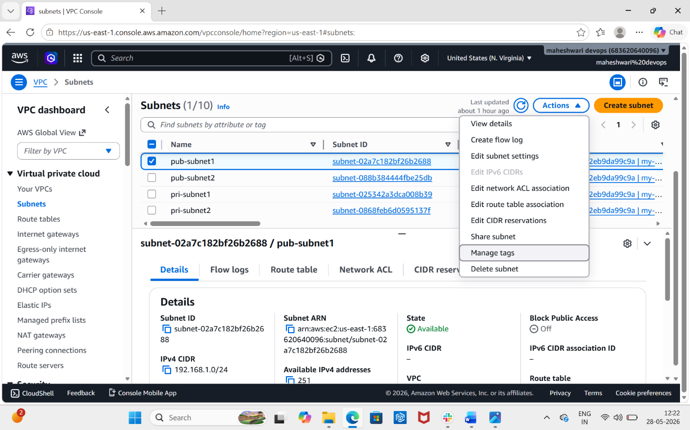

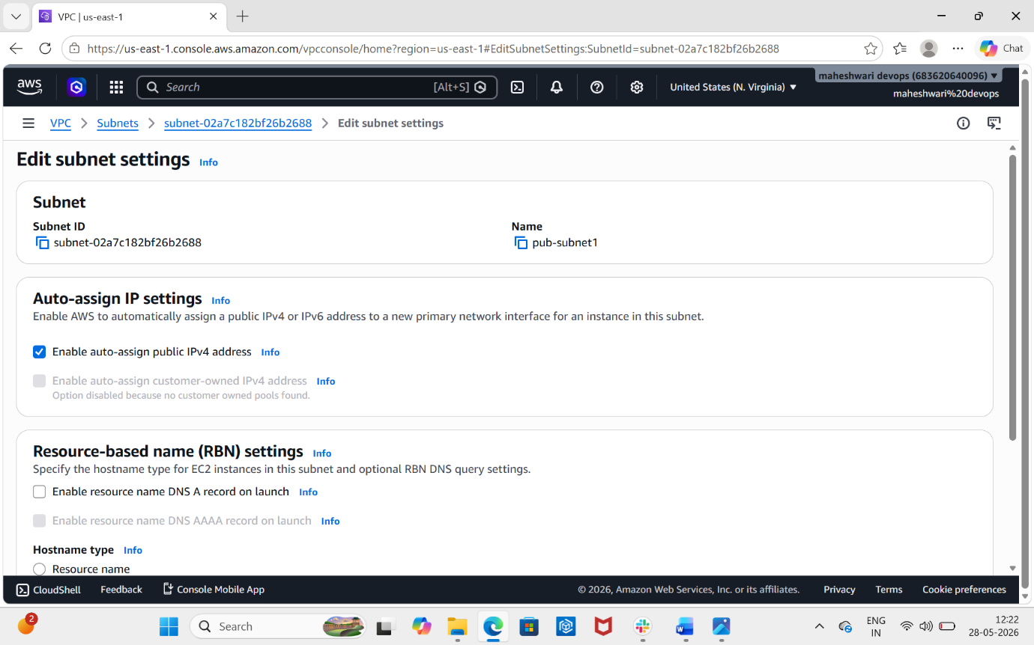

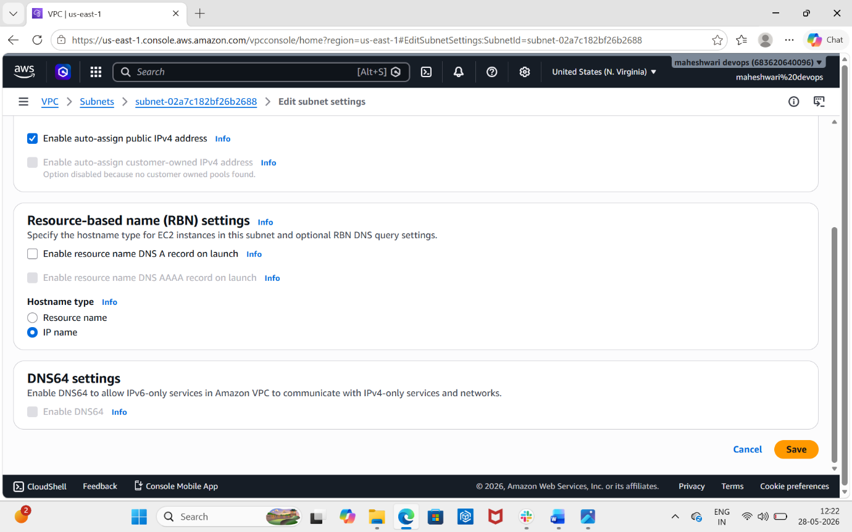

4. Add 2 private subnets in private route table.

PURPOSE: Adding two private subnets to separate private route tables ensures high availability and fault tolerance.

OBJECTIVE: The primary objective of associating two private subnets with private route tables is to establish high availability and fault tolerance across multiple availability zones.

OUTCOME: The outcome depends on your architecture, but it typically allows instances in both subnets to communicate privately within your VPC while preventing direct inbound traffic from the internet.

STEP BY STEP IMPLEMENTATION:
- Open VPC Dshboard.
- In the navigation pane, select route tables.
- In route table console, create a route table with the name private-rt and select the VPC.
- Then click on create route table.

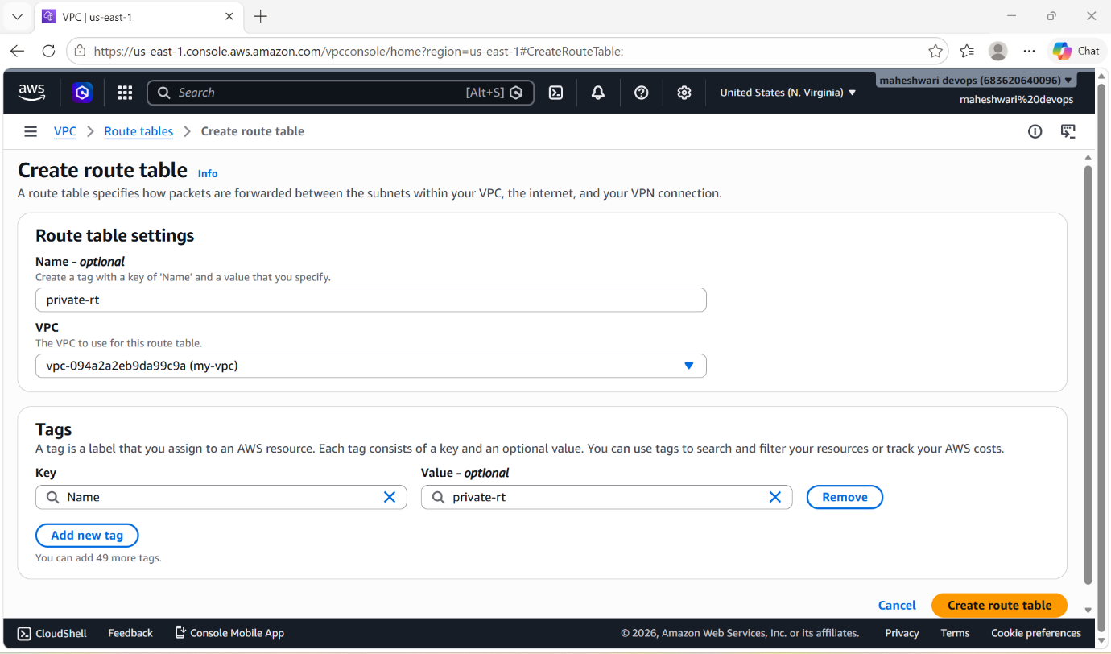

- To add two private subnets, click on actions it will drop down some options.
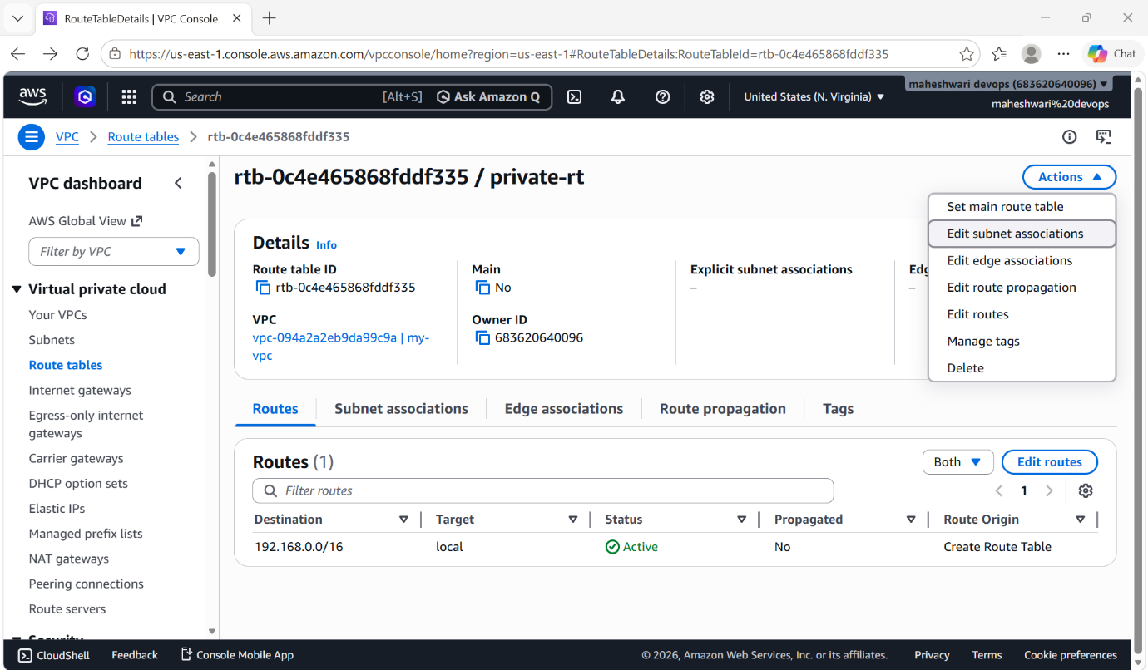

- In that options select edit subnet associations and add that 2 private subnets of our vpc.

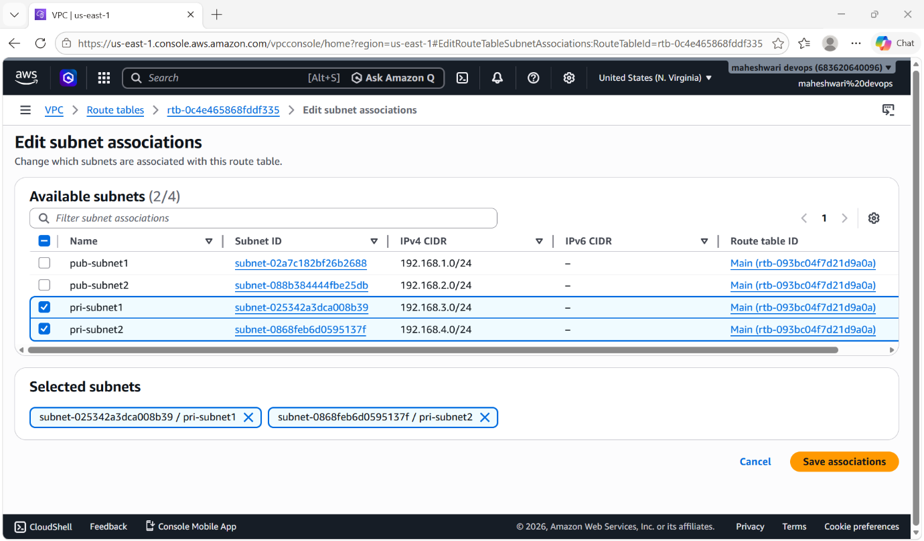

- Then click on save and it will associate our private subnets with the private route table.

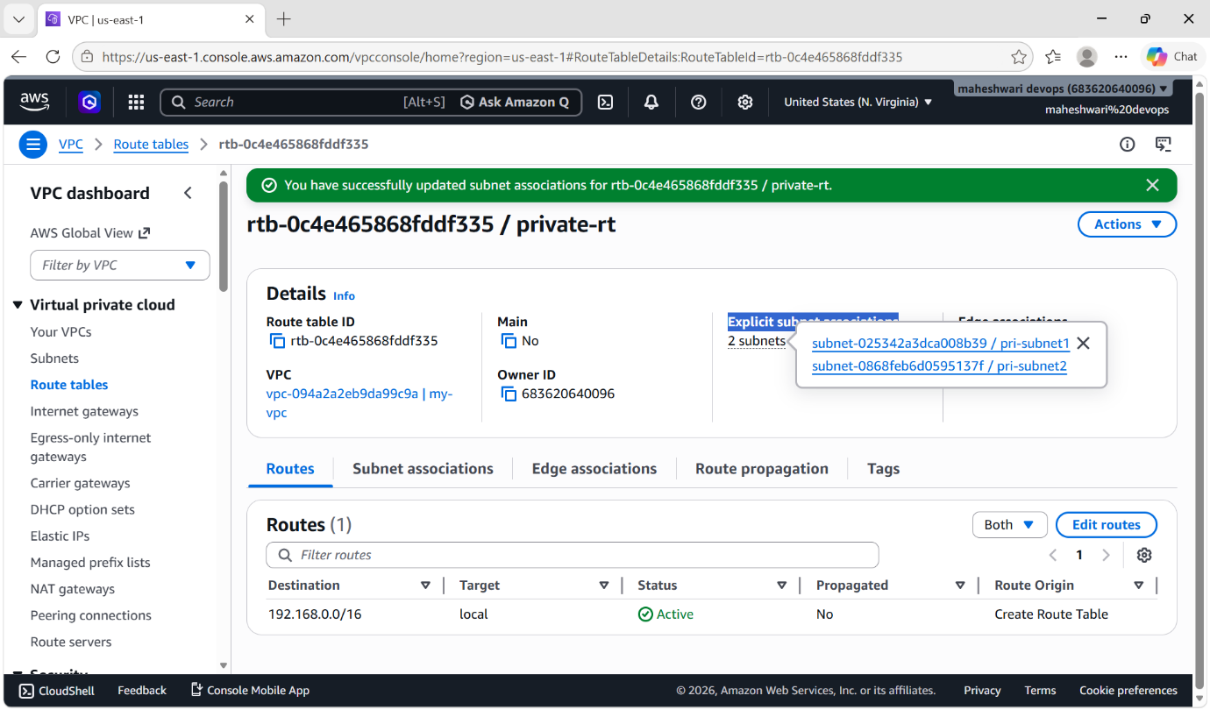

5. Add 2 public subnets in public route table

PURPOSE: Adding two public subnets to a public route table is a standard cloud architecture practice designed to achieve High Availability (HA) and fault tolerance across multiple data centers.

OBJECTIVE: It ensures internet traffic routes correctly to and from your network.

OUTCOME: Adding two public subnets to a public route table configures them to send internet-bound traffic directly to an internet gateway (IGW).

STEP BY STEP IMPLEMENTATION:

- Open VPC Dshboard.
- In the navigation pane, select route tables.
- In route table console, create a route table with the name private-rt and select the VPC.
- Then click on create route table.

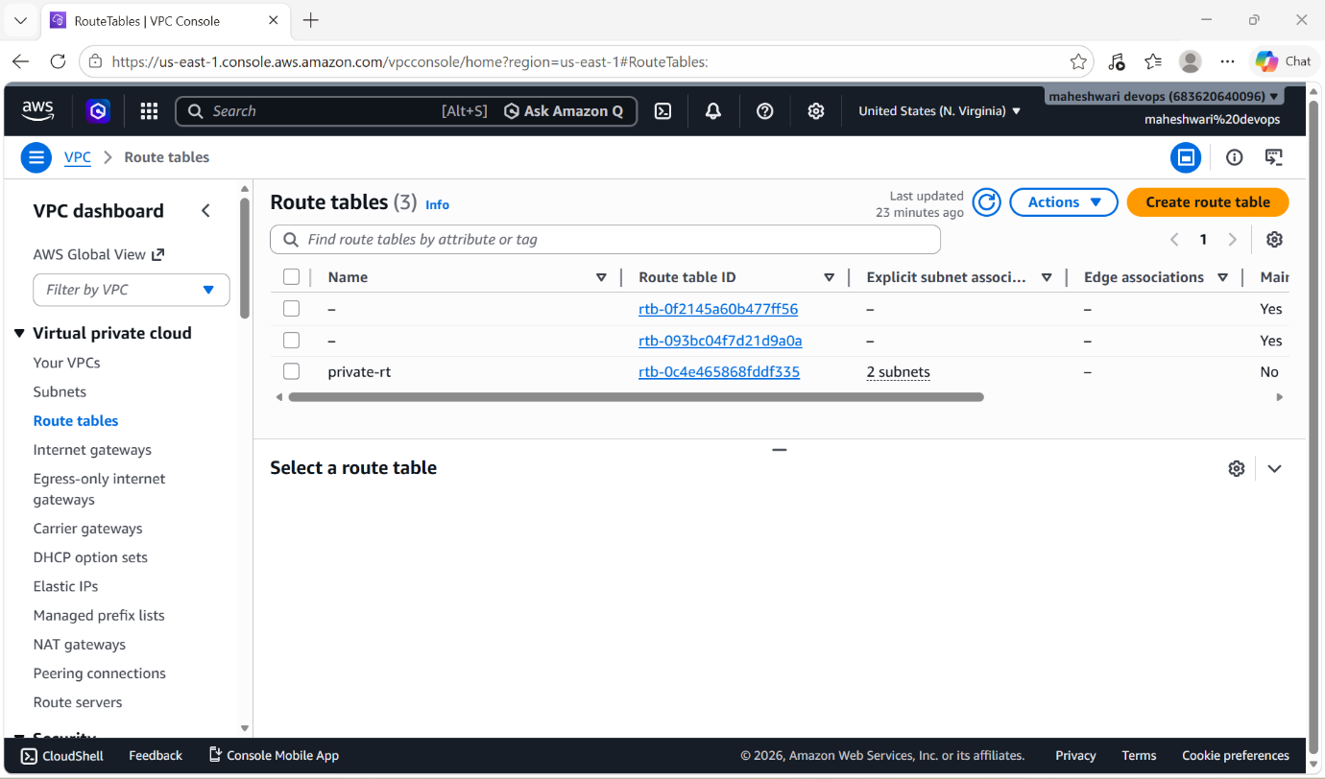

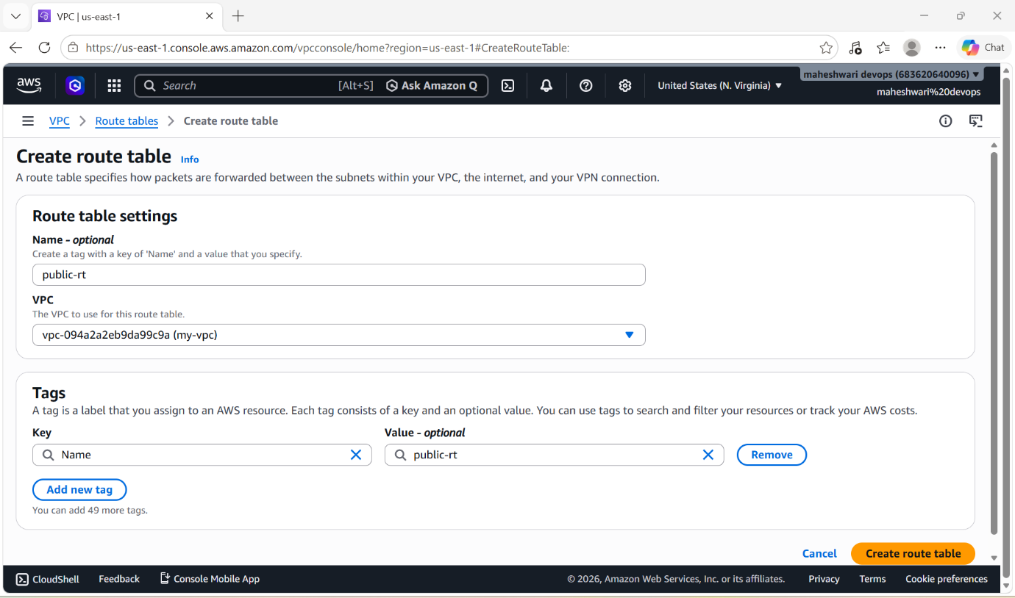

- Add internet gateway, a public subnet must have a route to the internet gateway (IGW)
- IGW : An AWS Internet Gateway is a horizontally scaled, highly available VPC component that connects your VPC to the public internet.
- To create IGW, in the nagivation pane go to internet gateway console.
- Click on create an internet gateway and create the internet gateway with the association of VPC.

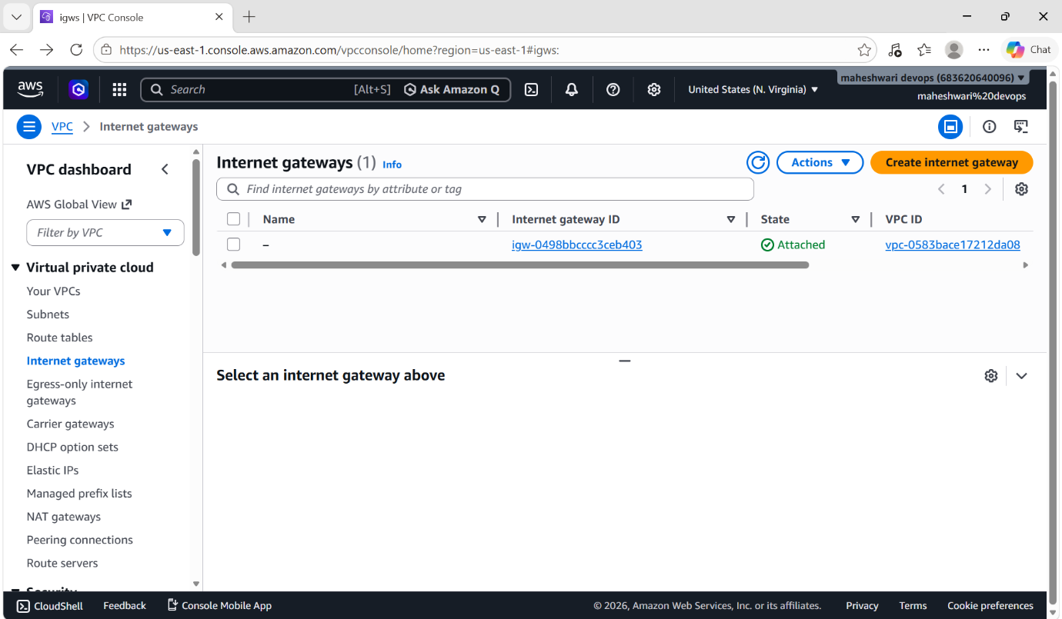

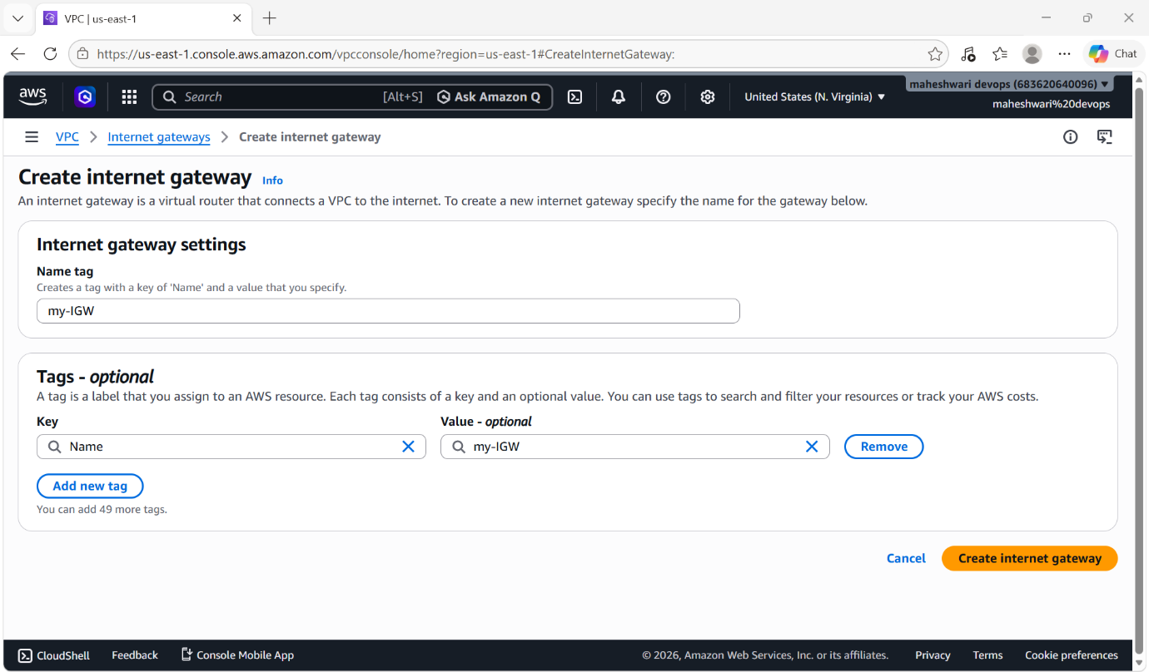

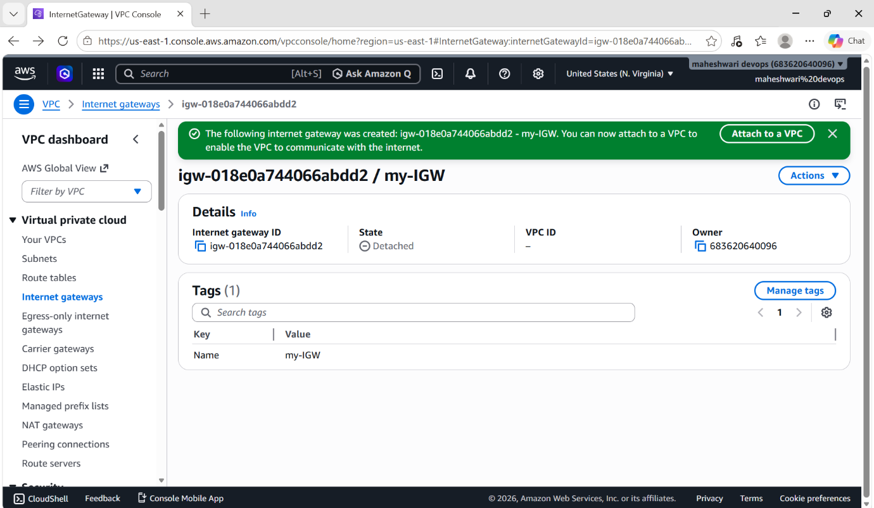

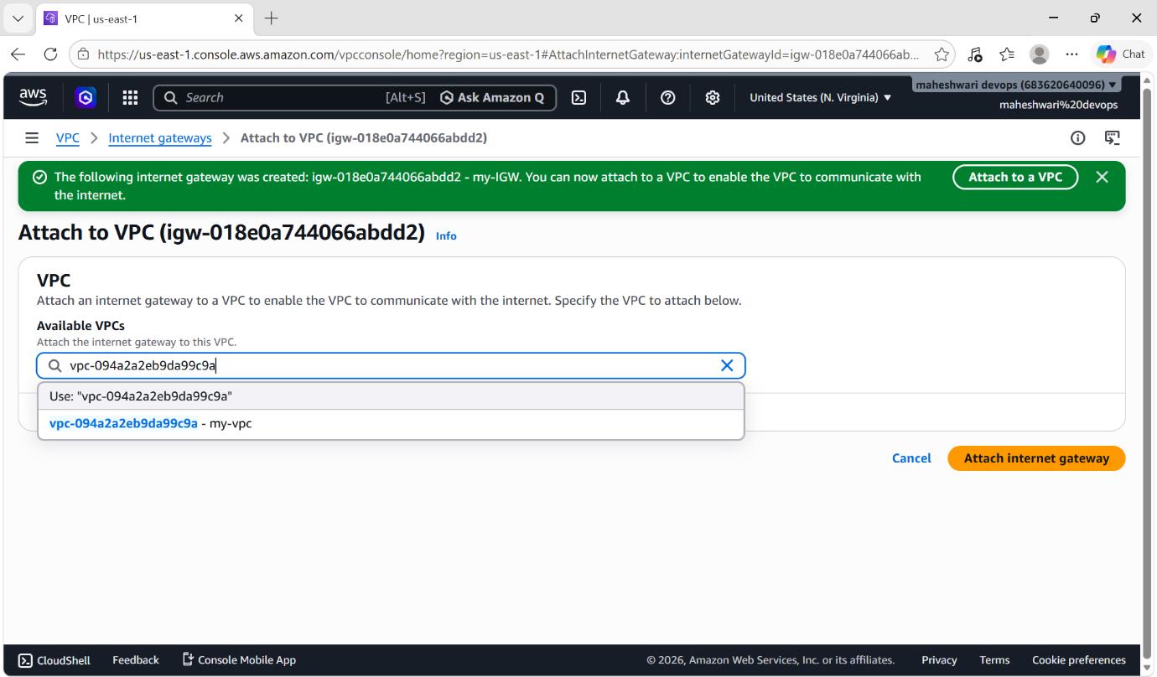

- For the public route table that we have created, give the IGW connection by clicking on edit routes.
- In that option add destination as 0.0.0.0/0 and the target name internet gateway that we have created.

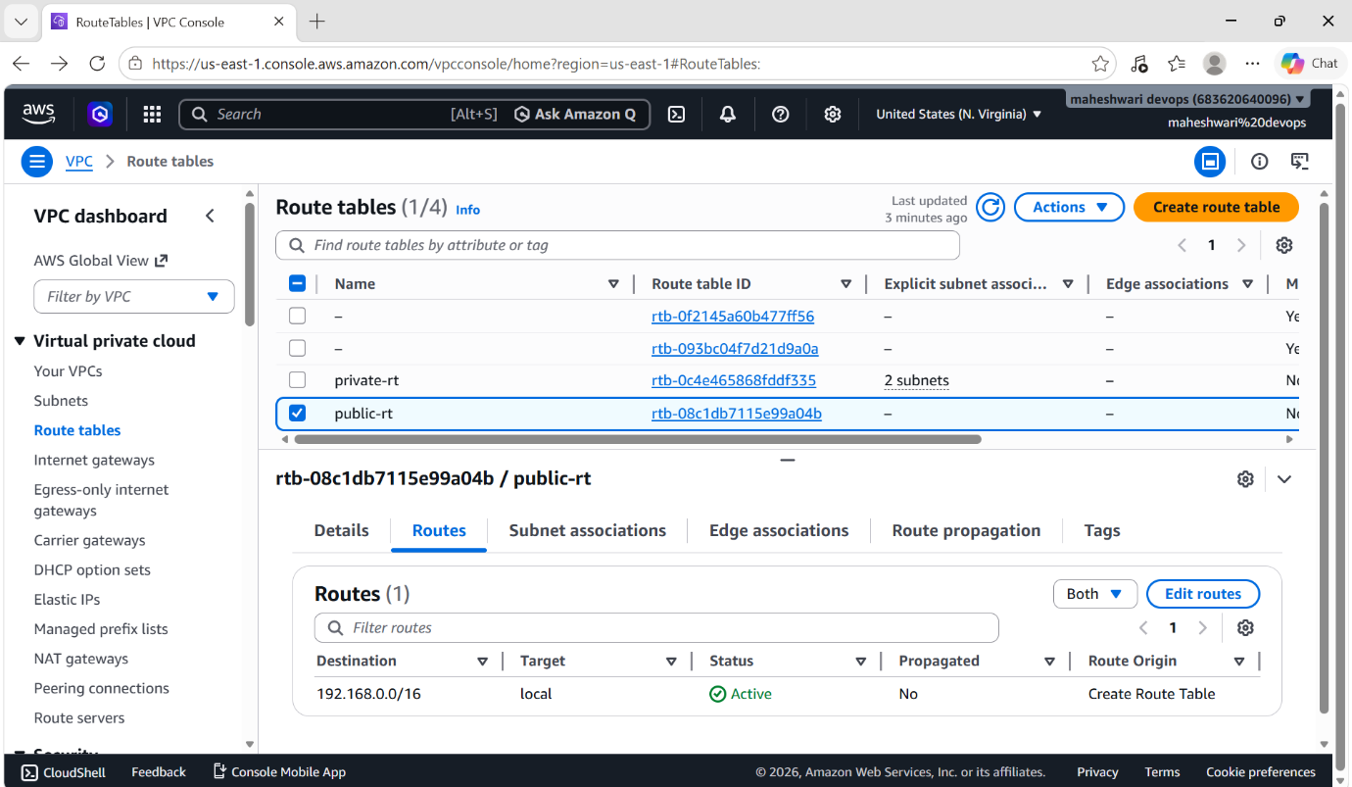

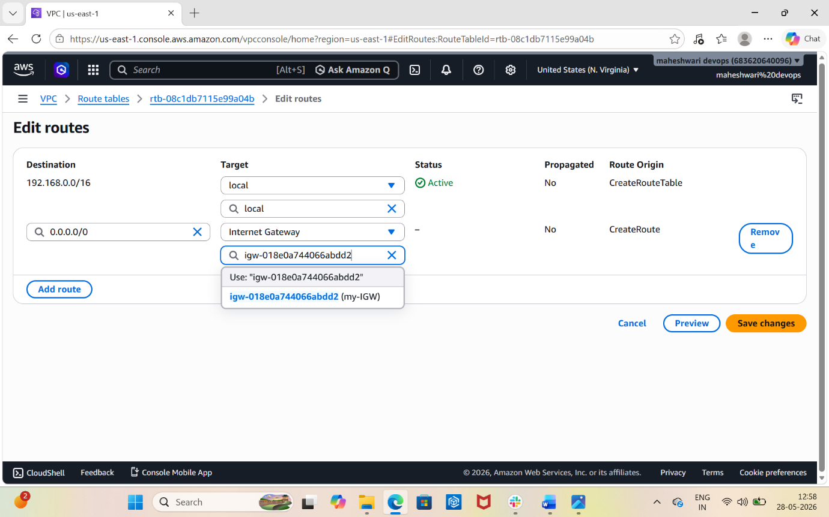

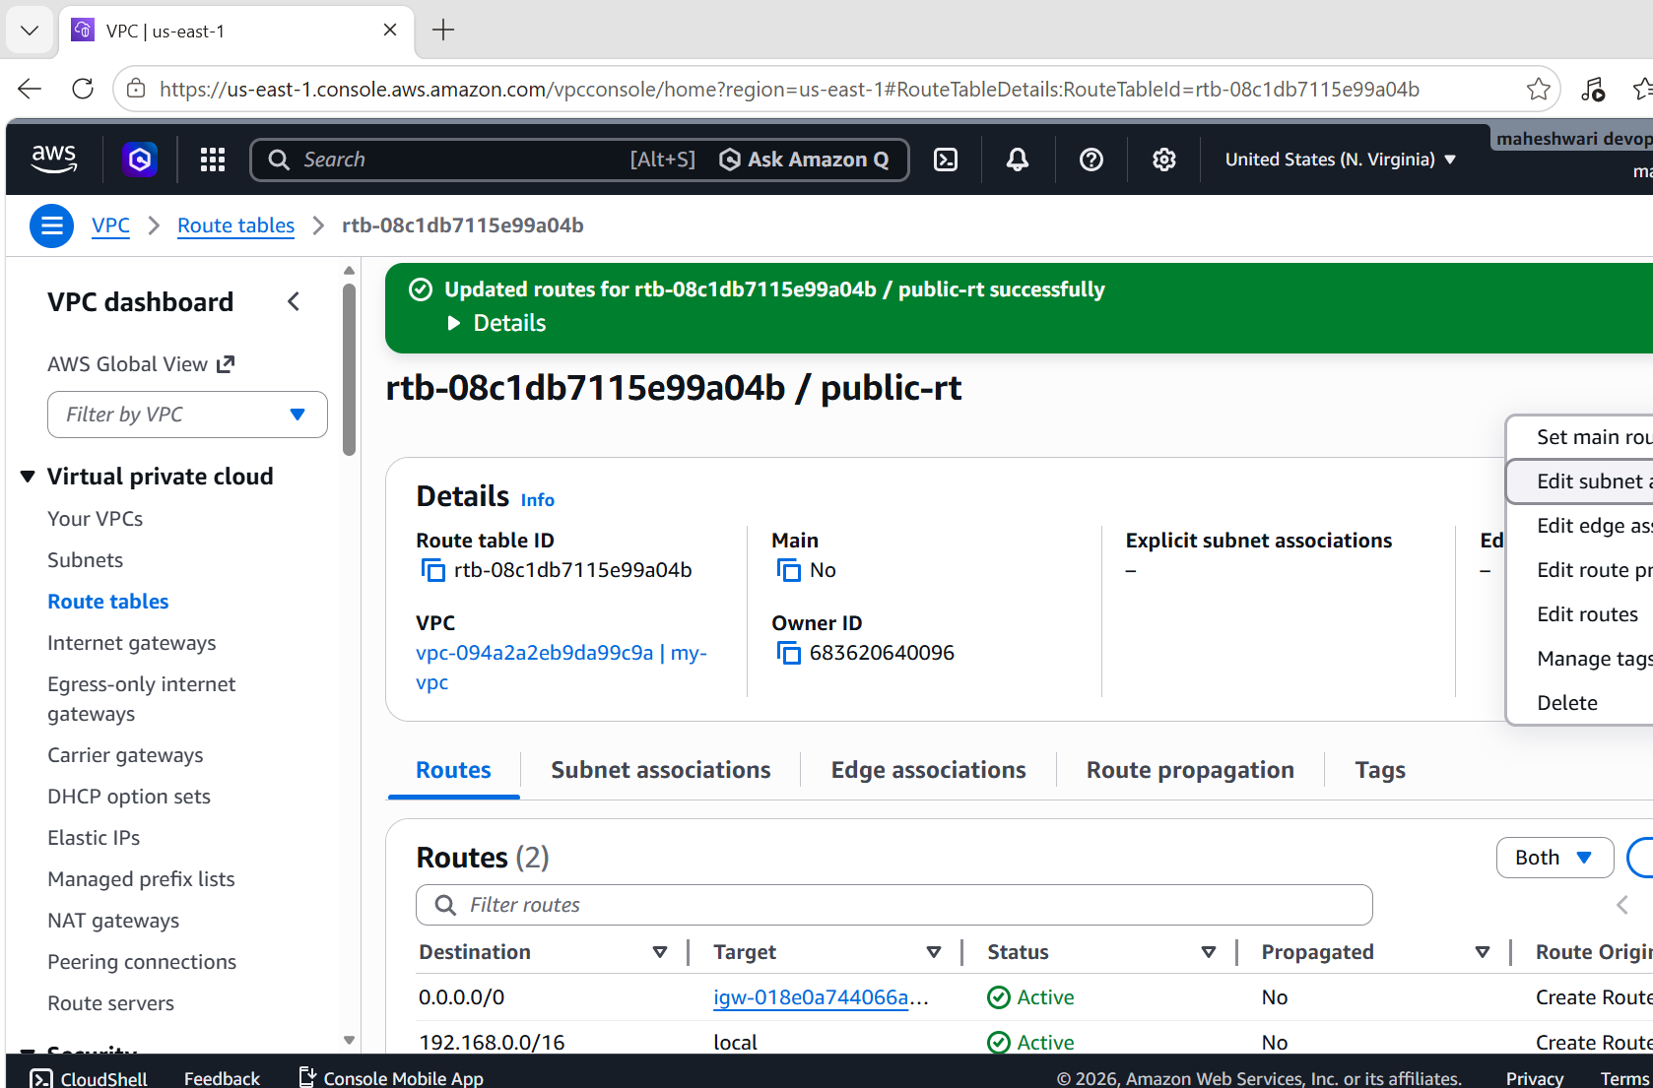

- Then associate the two public subnets to the public route table by clicking on action it will drop down some options
- In that option select edit subnet associations.
- It will open one console with subnets that we have.
- In that subnets add the subnets with the public subnet names.

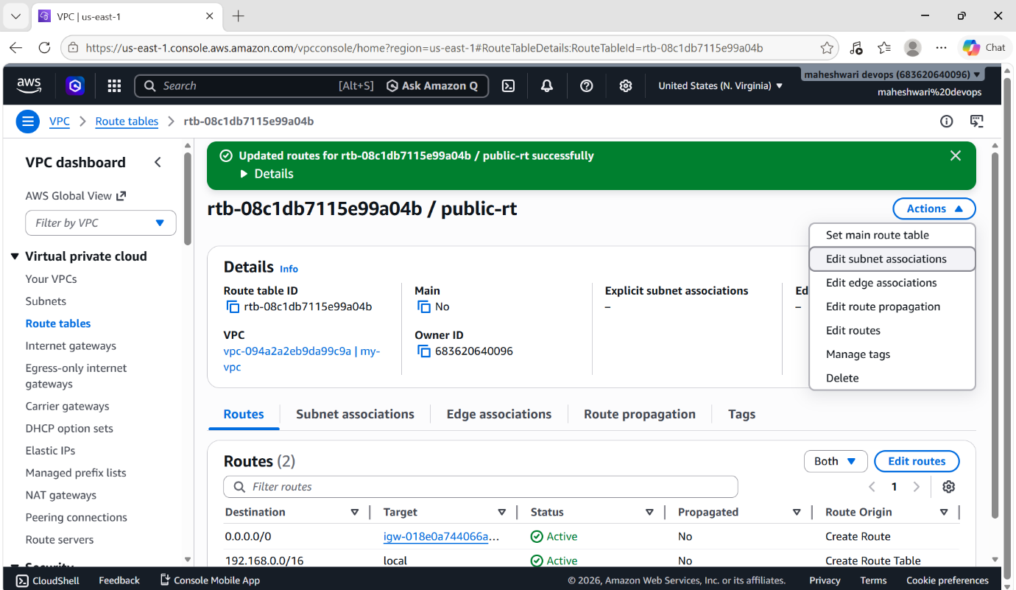
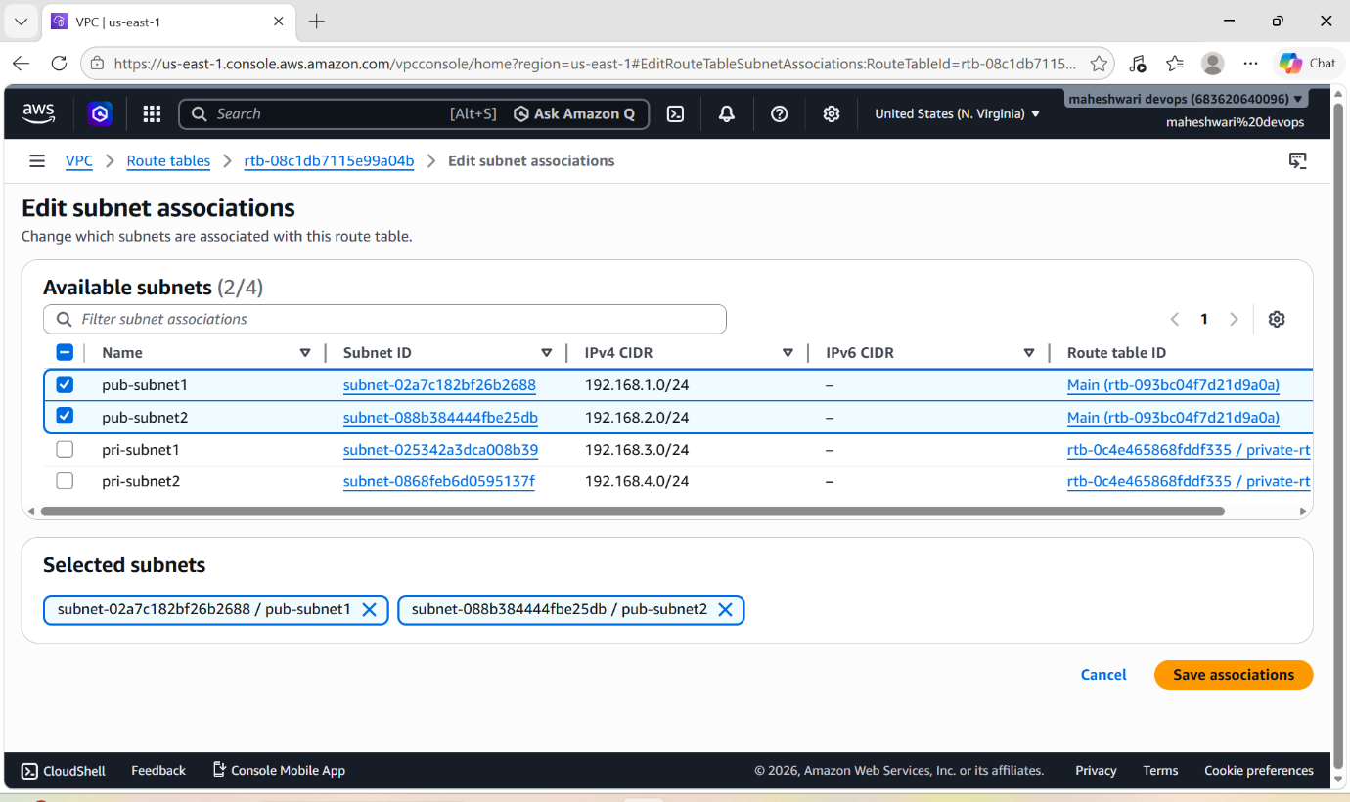

- Then click on save associations and it will add the subnets successfully.

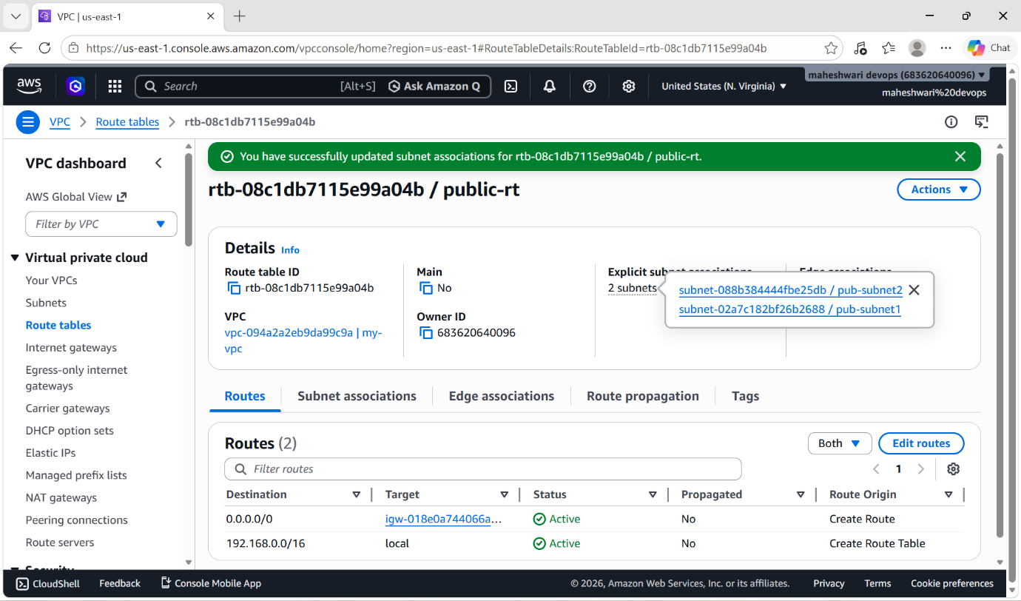

6. Public route table will have the routes to internet and local.

PURPOSE: The primary purpose of a public route table is to direct traffic within your cloud network(local) and provide outbound/indound access to the outside world.

OBJECTIVE: The objective of a public route table is to direct traffic out to the public internet and allow communication within the local network (VPC).

OUTCOME: A public route table explicitly contains a local route for internal communication within your network and a default route (0.0.0.0/0) pointing to an internet gateway to allow resources to connect to the public internet.
- Local route : 192.168.0.0/16
- Internet gateway : 0.0.0.0/0

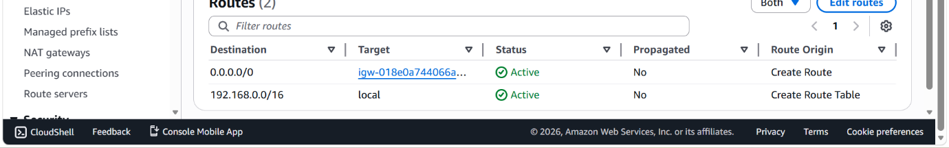

7. Create EC2 in public subnet with t2.micro and install PHP.

PURPOSE: The primary purpose of deploying an Amazon EC2 instance in public subnet is to make it accessible from the internet. Using t2.micro instance type is typically intended for low-cost development, testing or hosting small web-applications.

PURPOSE OF PHP: The primary purpose of php in web development is to serve as a server-side scripting language that generate dynamic and interactive content for websites.

OBJECTIVE: The primary objective of deploying an Amazon EC2 instance in a public subnet with a t2.micro type and PHP is to establish a cost-effective, internet-accessible web server environment for hosting dynamic web applications.

STEP BY STEP IMPLEMENTATION:

- Login into AWS console.

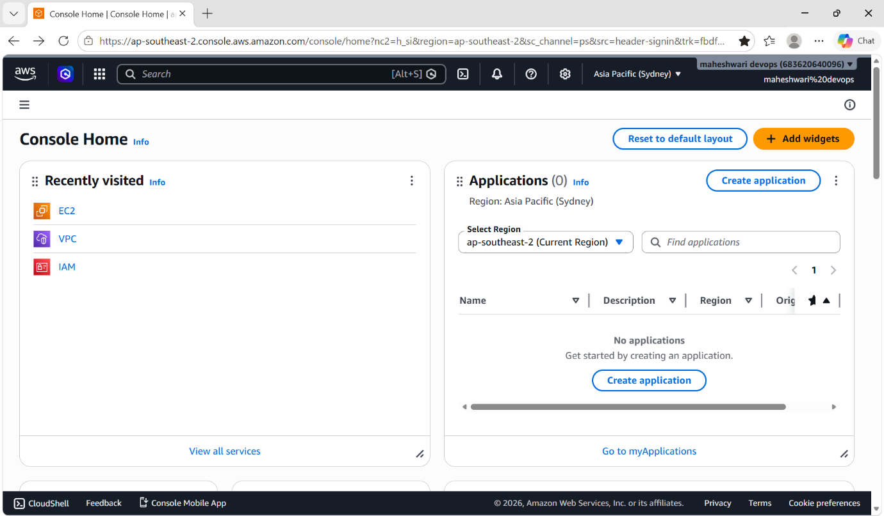

- In the navigation pane, go to EC2 service.
- Click on launch instance and it will drive to the page to launch instance.
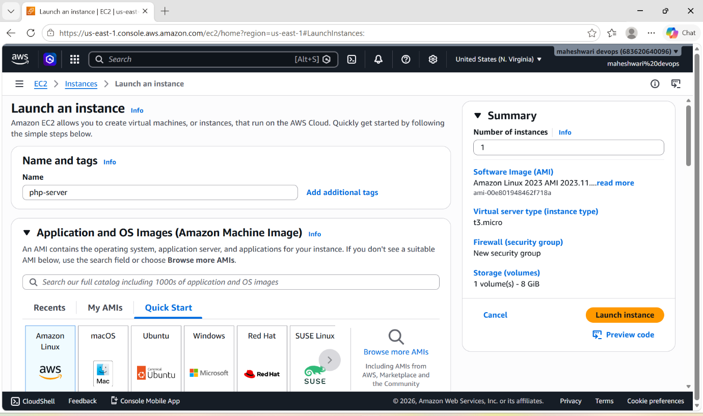
- Allocate one VPC and public subnet to the instance.
- Select for existing security group and edit the inbound rules for ssh and all traffic.

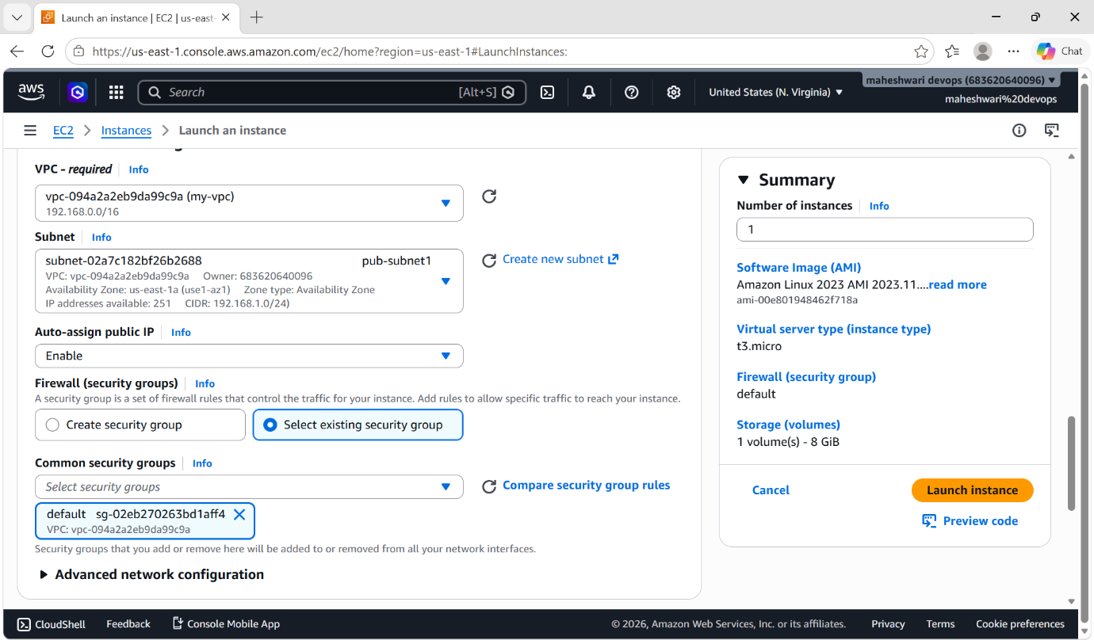

- Click on launch instance and it will create one instance for us.

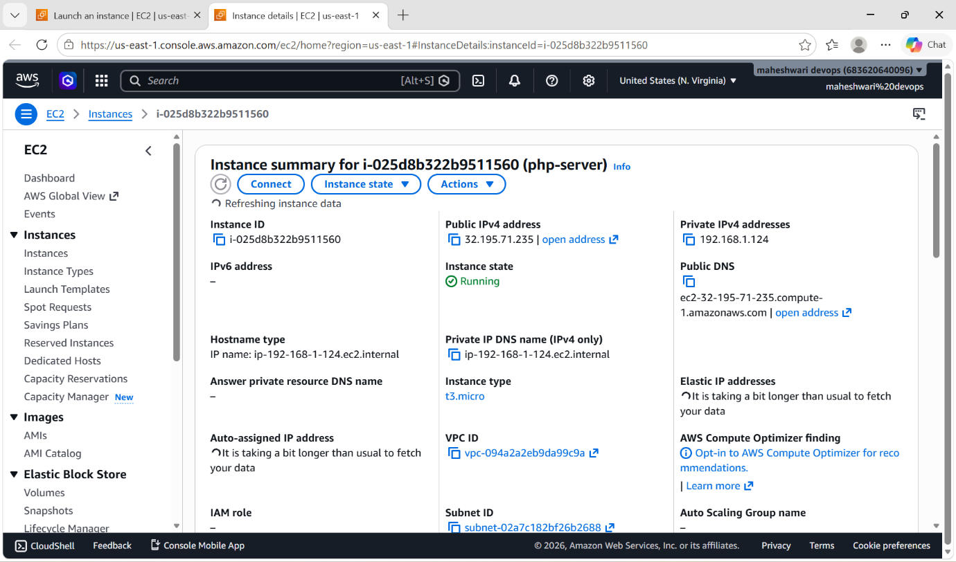

- Connect to the EC2 instance by git bash -> ssh -i file.pem ec2-user@public-IP and switch to root user.
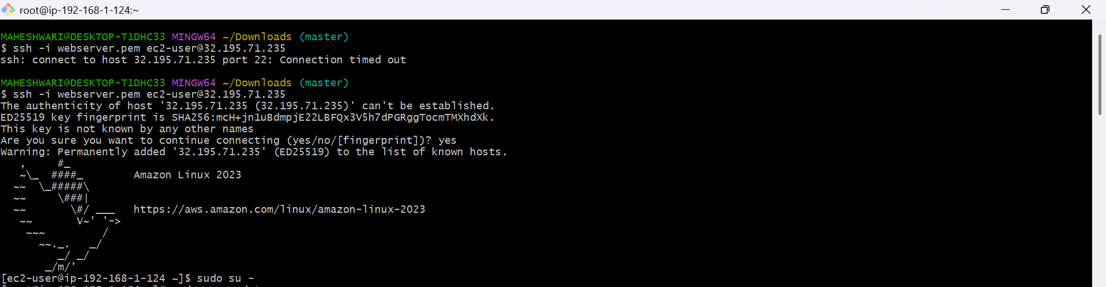

- To install one service, check for the updates first and then install the service
-> sudo yum update -y
-> sudo yum install nginx -y
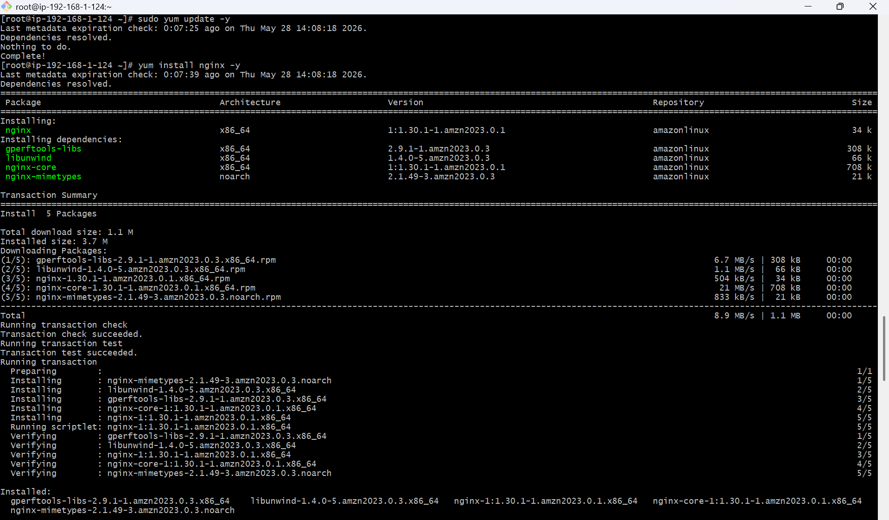
- And start that service that we have installed and check for the status of the service.
-> sudo systemctl start nginx
-> sudo systemctl status nginx
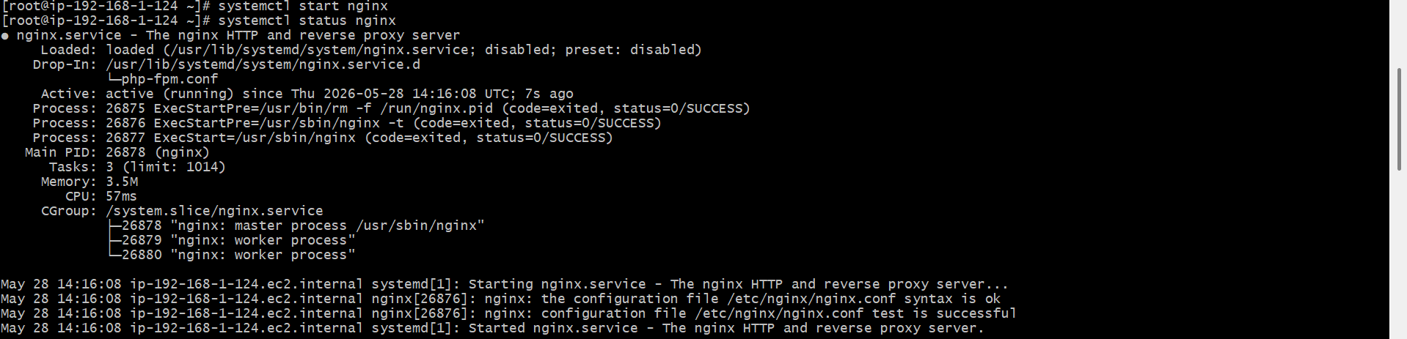

- Now install php service before that check for the updates.
-> sudo yum update -y
-> sudo yum install php-fpm -y
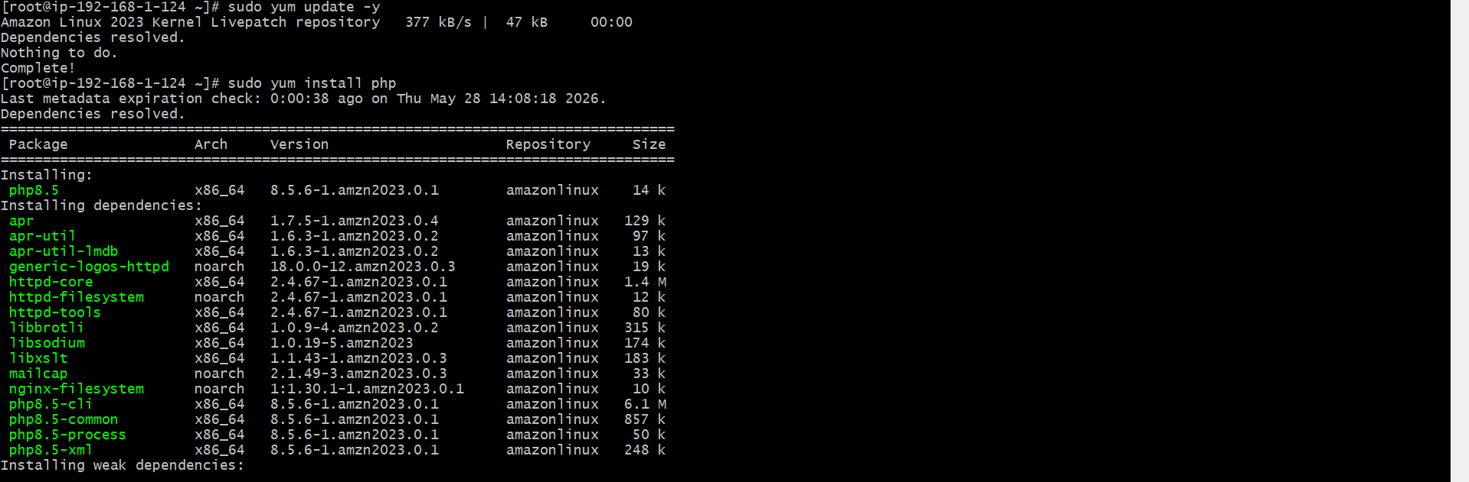

- After installing start that service and check for the status.
-> sudo systemctl start php-fpm
-> sudo systemctl status php-fpm

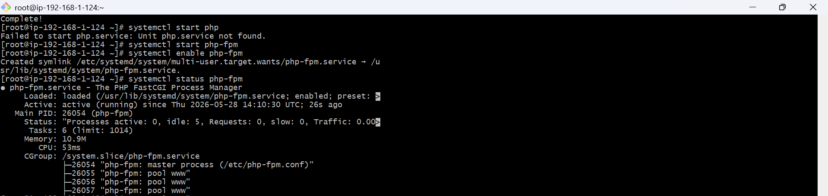

- Create a php.info file in /usr/share/nginx/html/info.php path by using vi editor -> vi /usr/share/nginx/html/info.php
- In that file add the content.

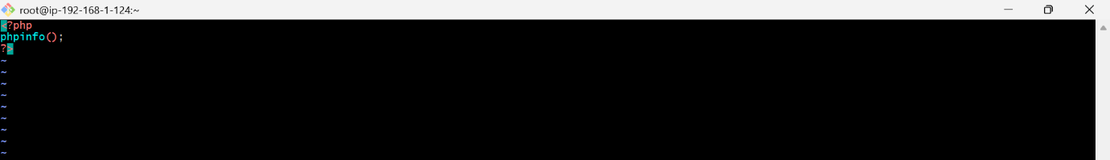
- Add configuration details in /etc/nginx/nginx.conf path by using vi editor -> vi /etc/nginx/nginx.conf

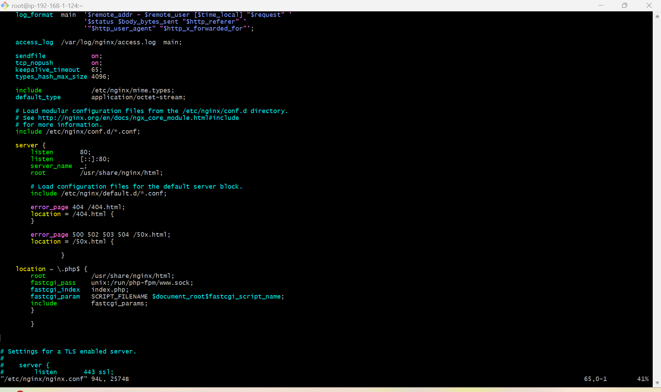

- To check whether the nginx.conf file is correct or having some issues by using the command -> sudo nginx -t
- By executing this command, u will get the result if file content is correct then it will show
-> syntax is ok
-> test is completed
OR if the content is wrong then it will show error as issues at the specific lines.

- Execute these commands to start the services
-> sudo systemctl restart nginx
-> sudo systemctl restart php-fpm
- Then check for the status of both services.
- To Verify if the php service is running on browser, use -> http:/public-IP/php-info

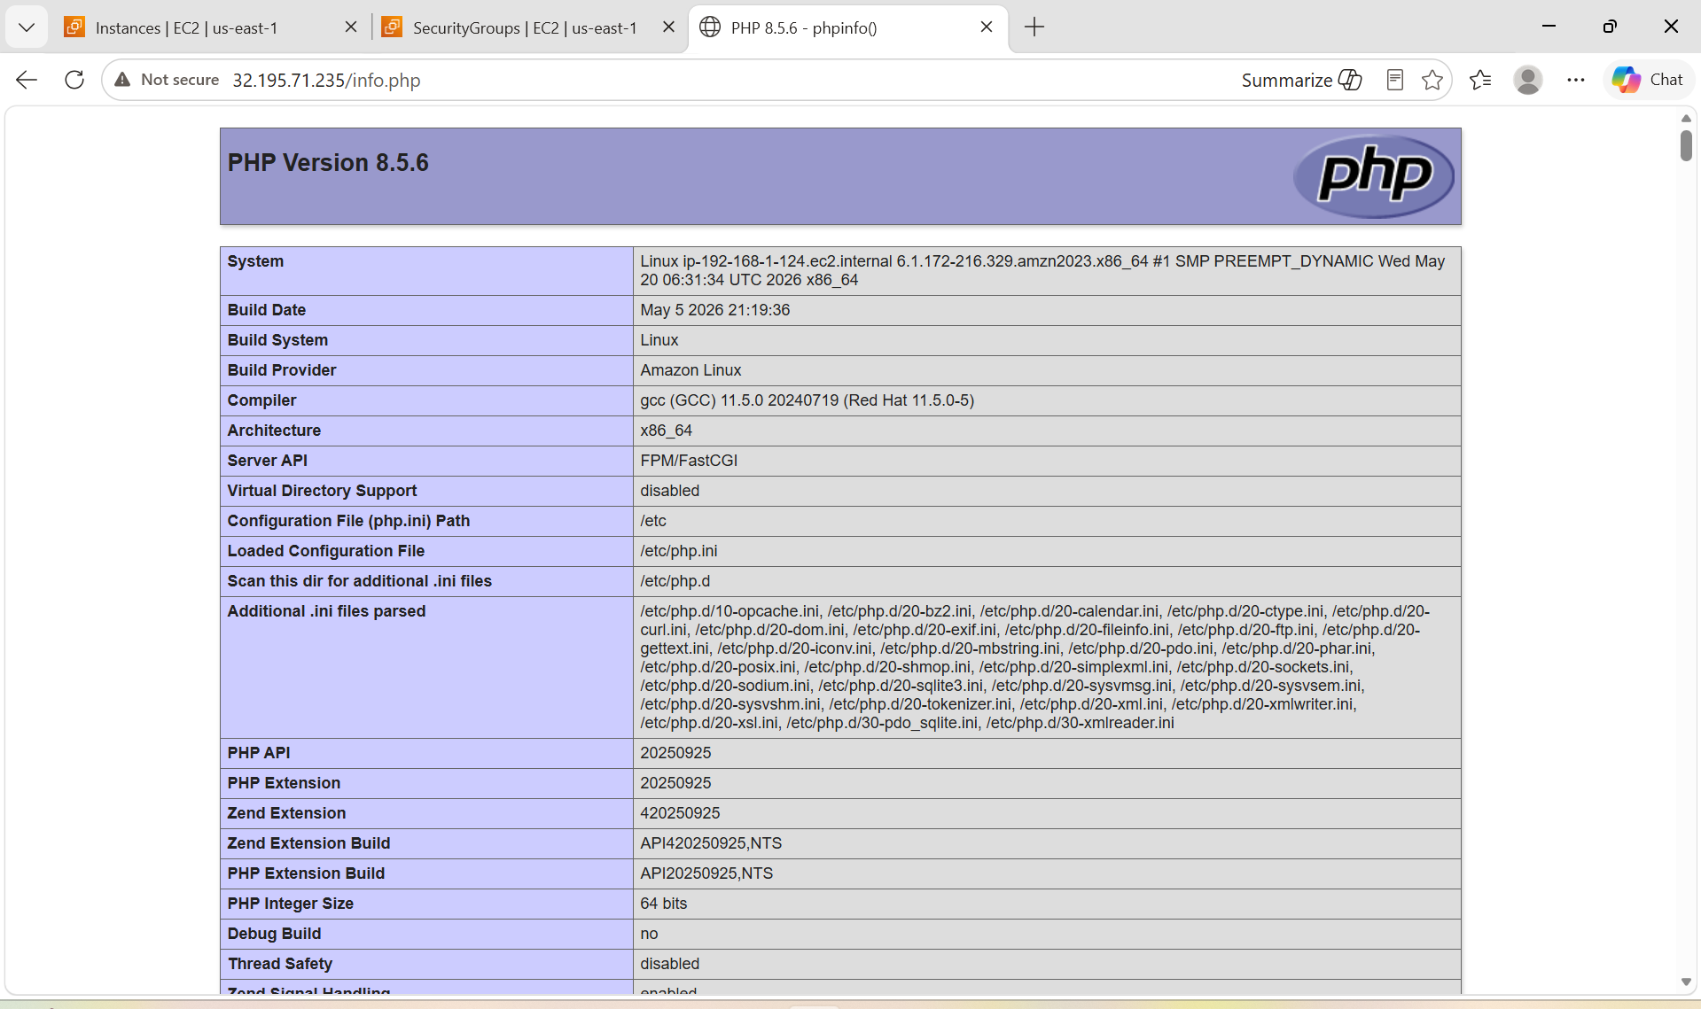

8. Configure NAT gateway in public subnet and connect to private instance.

PURPOSE: The purpose of configuring a NAT gateway in a public subnet and connecting it to a private instance is to enable outbound internet access for instances in the private subnet while maintaining security.

OBJECTIVE: The objective of configuring a NAT gateway in a public subnet and connecting it to a private instance is to enable private instances to send outbound traffic to the internet while preventing the internet from establishing connections to those instances.

OUTCOME: It will launch two instances that one is with public subnet and one is private subnet with the public security groups with ssh access.

STEP BY STEP IMPLEMENTATION:
- First of all, create a vpc with our own IPv4 CIDR range.
- Then create two subnets one is private subnet and one is public subnet.
- And also enable auto assign public IP for public subnet.
- And for private subnet don’t enable auto assign public IP.
- Then create a internet gateway and attach it for our created VPC.
- Now configure one public route table and add a route of internet gateway that allows all traffic 0.0.0.0/0
- In the navigation pane, go to NAT gateway and create a NAT gateway.
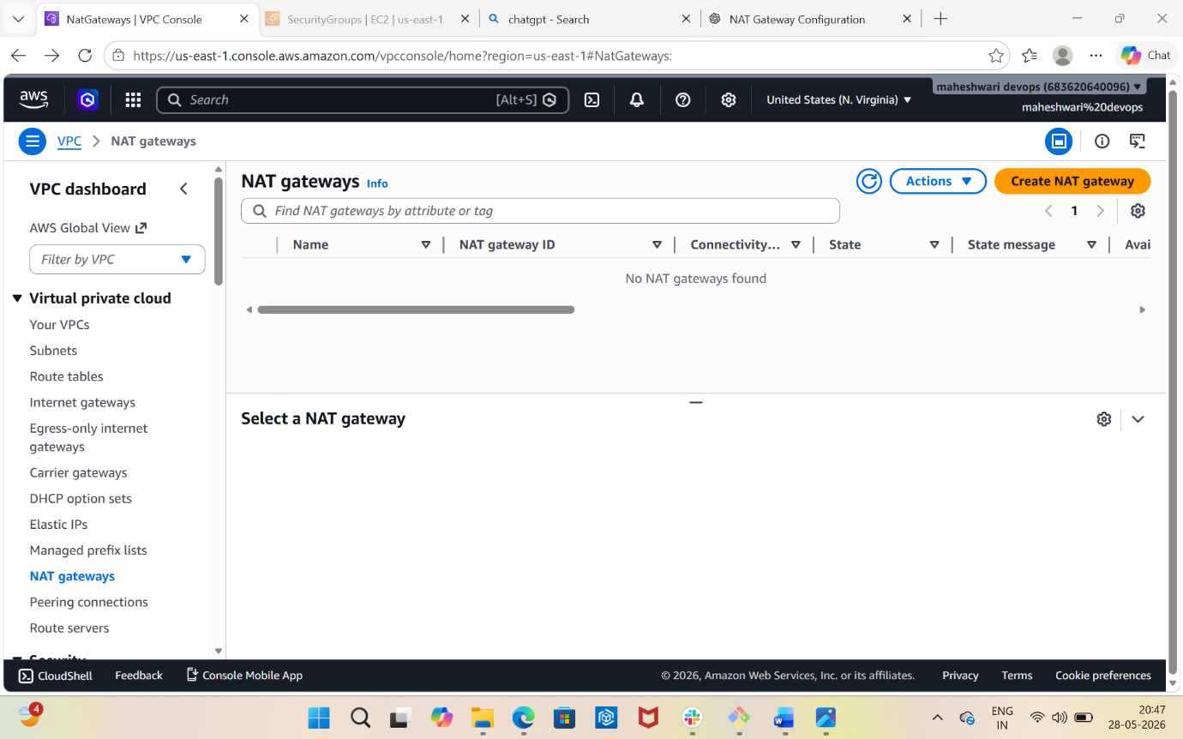

- Select on public subnet and allocate elastic IP.
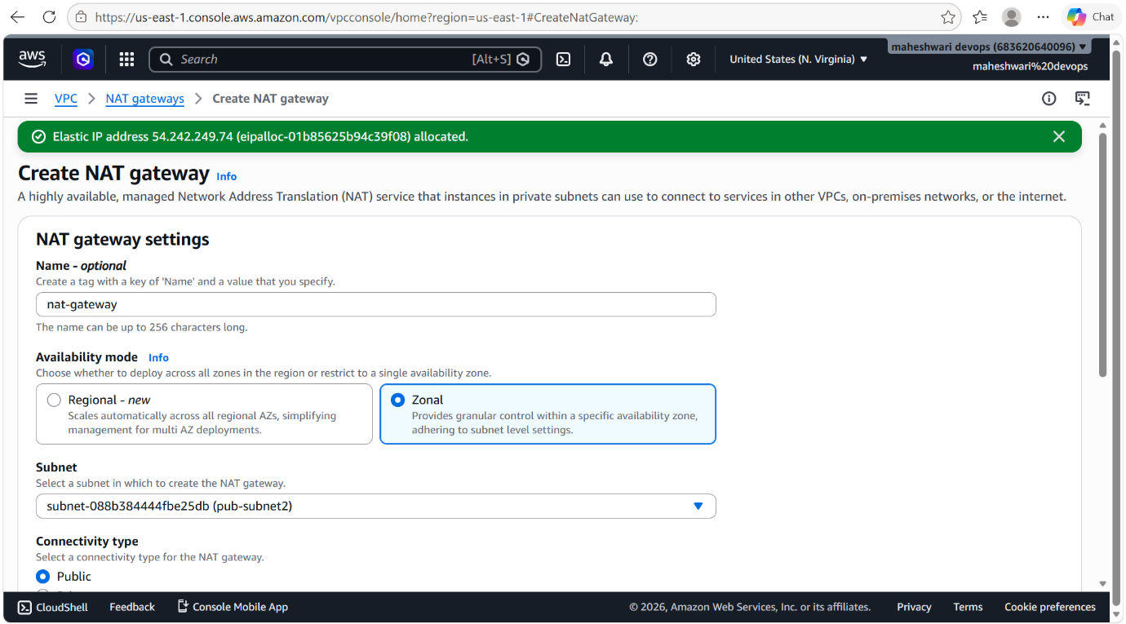

- Click on create NAT gateway and it will create a NAT gateway.

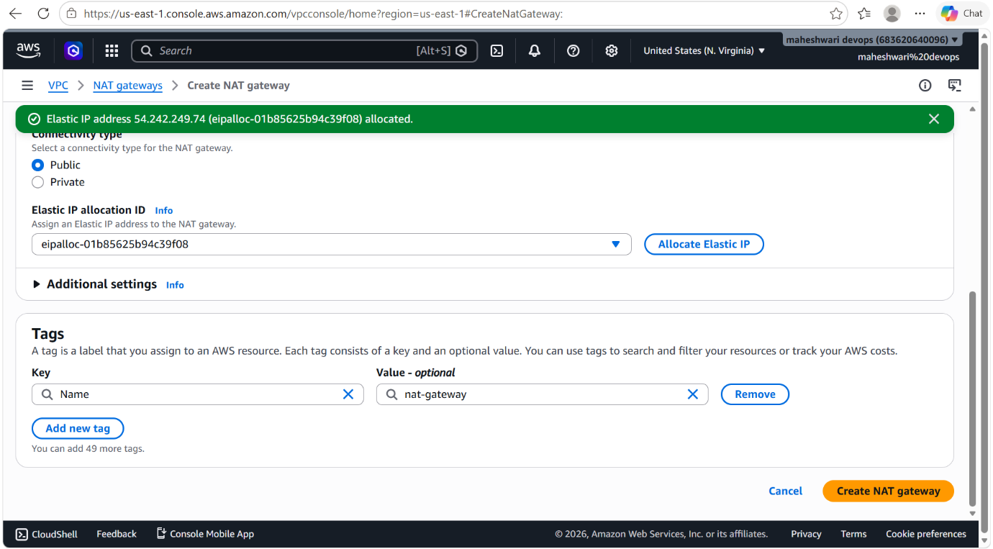

- Now this created NAT gateway is to associate with the private route table.
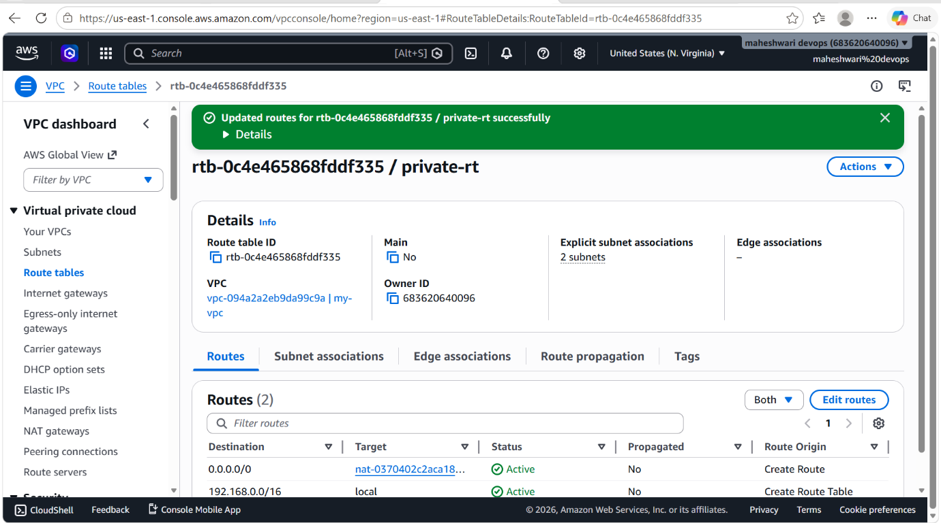

- Now launch two ec2 instances one instance should be in public subnet and another one should be in private subnet.
- For public subnet instance, click on auto-assign public IP and for private subnet instance it will automatically disables that option because for private instance, should not have the direct internet access.
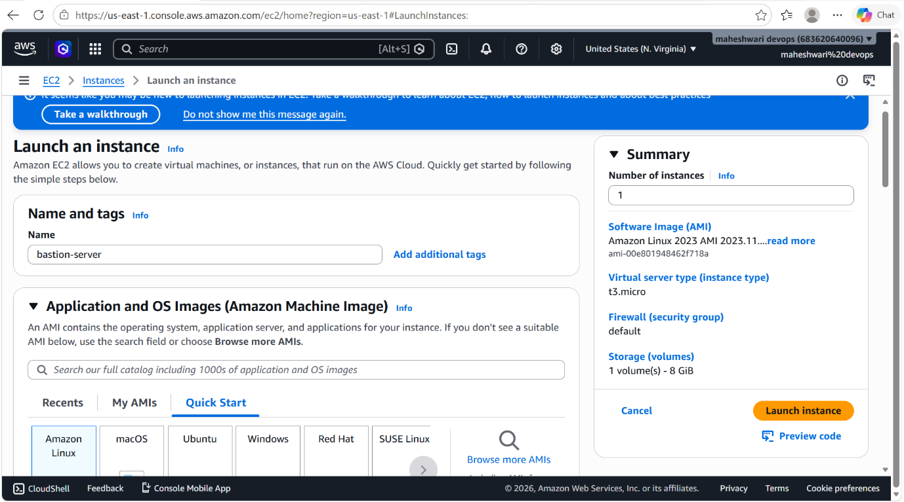

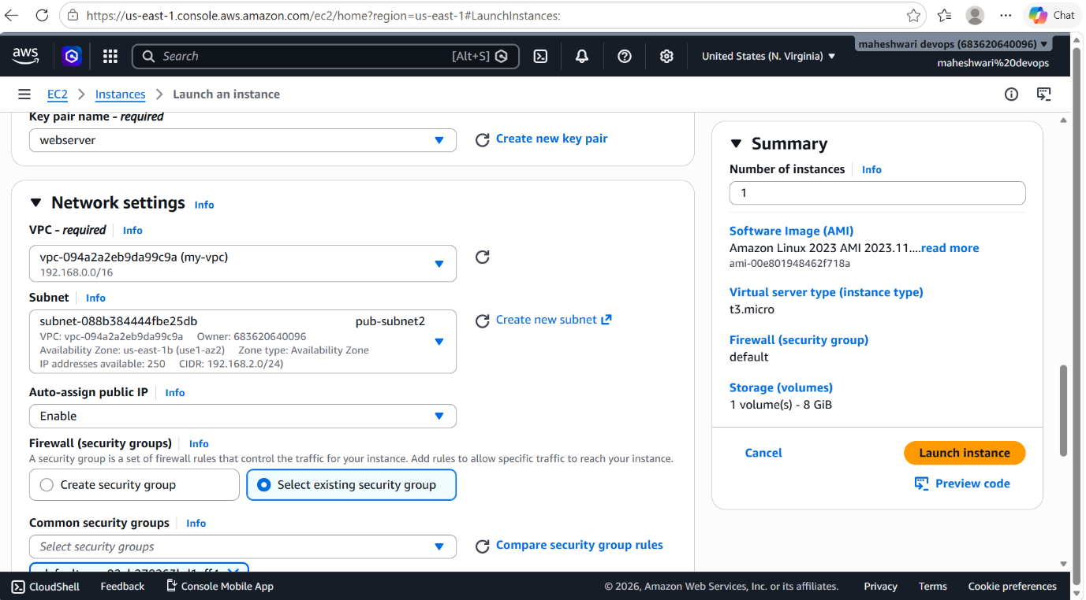

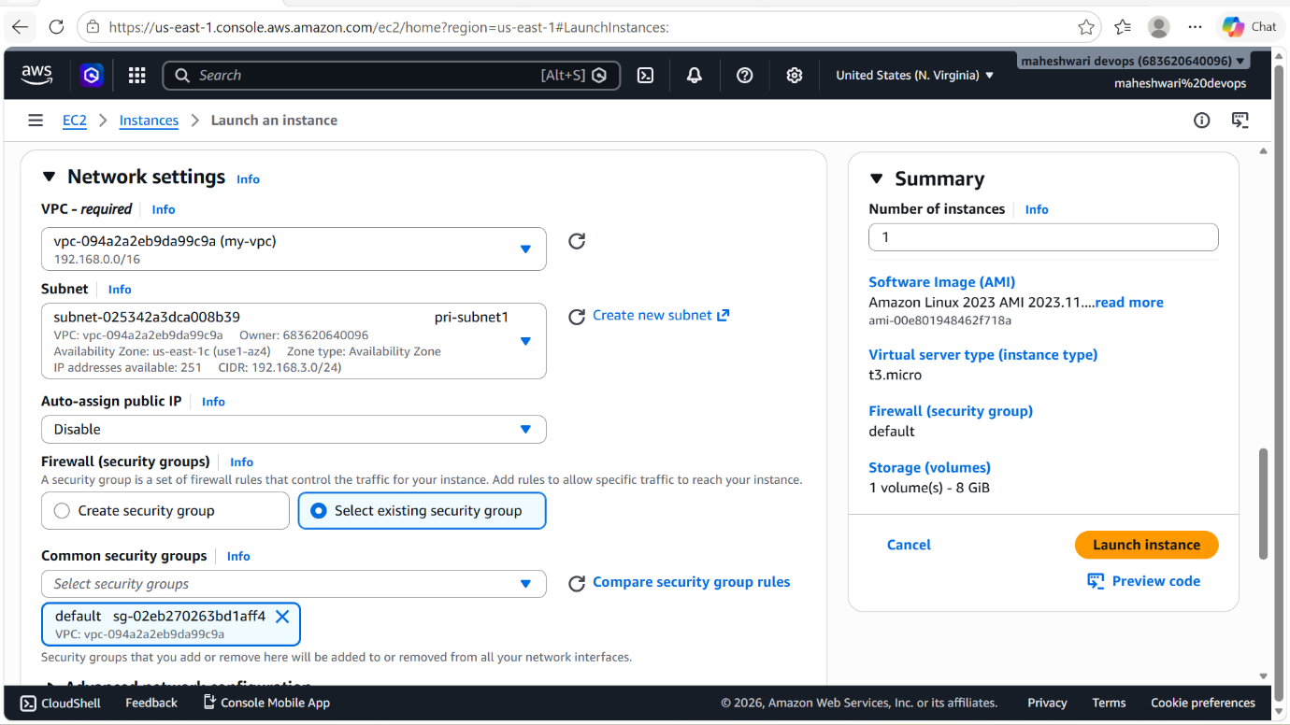

- Create a security group with the name of public security group.
- Edit inbound rules for the SG should be of 2 rules they are
-> SSH tcp 22 my-IP IP address
-> SSH tcp 22 custom 0.0.0.0/0
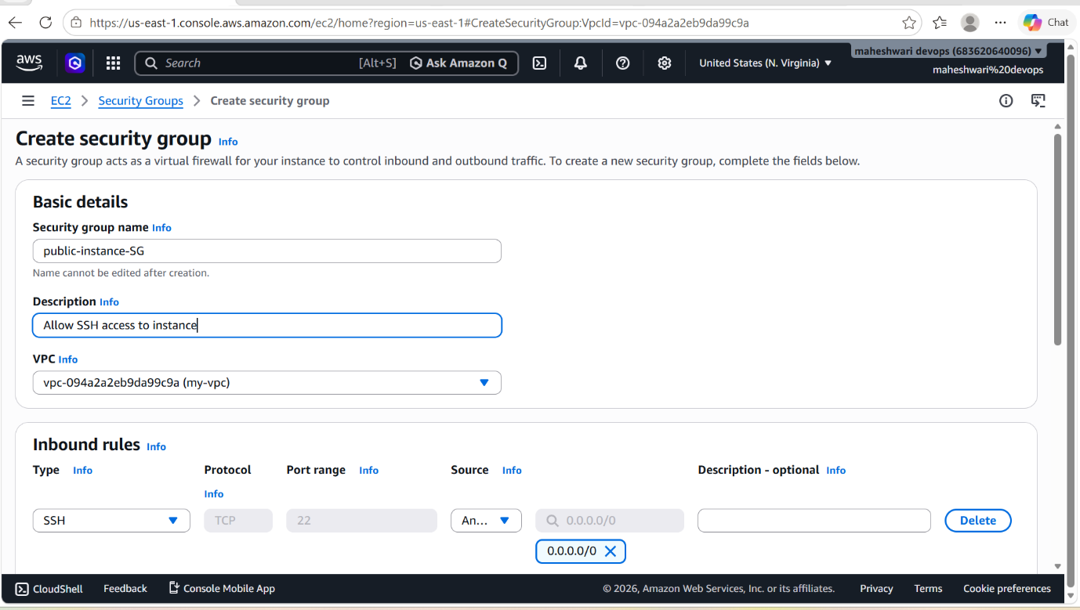

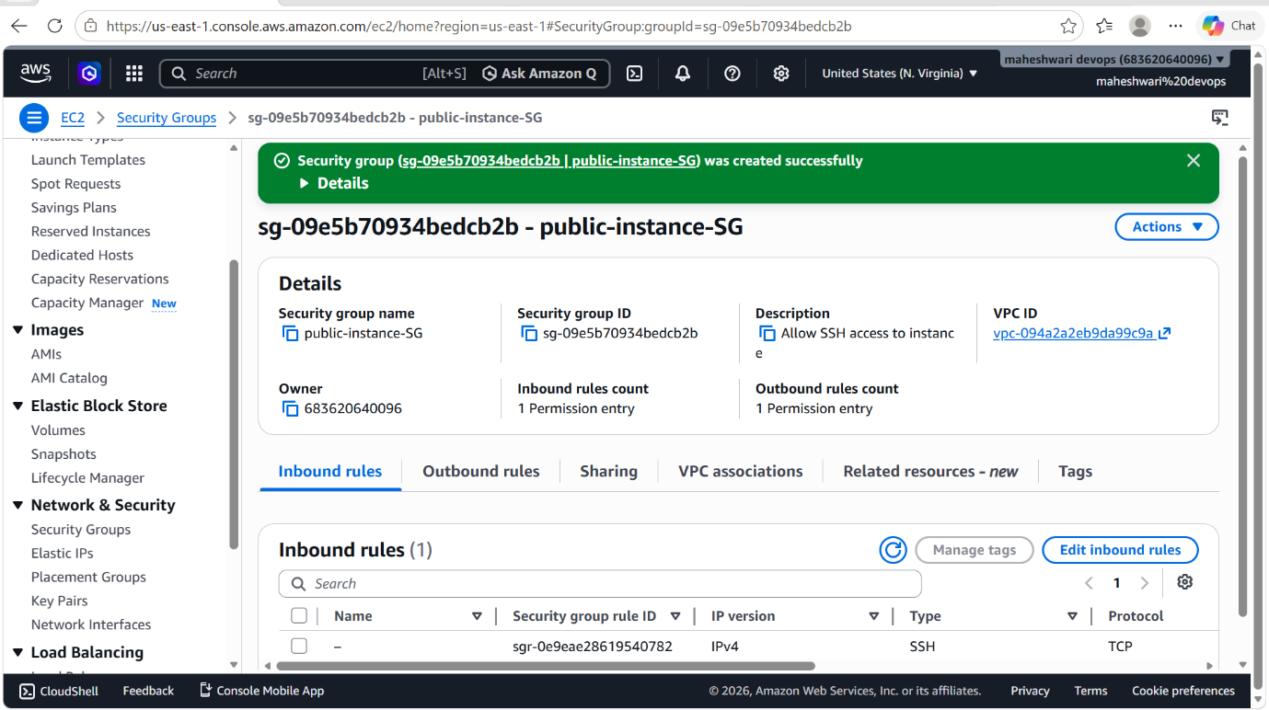

- Firstly connect to the public subnet with ssh login
-> ssh -i file.pem ec2-user@public-IP
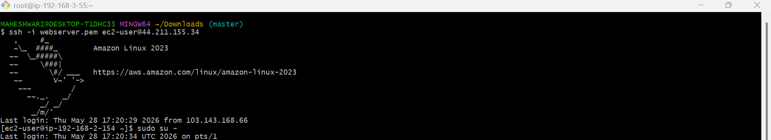

- Now we have to copy the pem file from the local machine to the public instance storage to login into the private instance
- For the copy of that file
-> scp -i webserver.pem webserver.pem ec2-user@private-IP:/home/ec2-user/

- Before that we have to change the permissions of the pem file by using the command -> chmod 600 webserver.pem
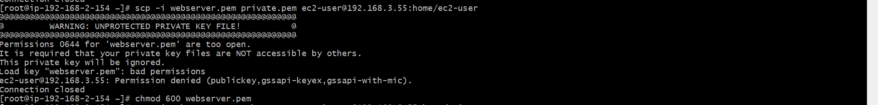

- Now we have the pem key to get login into that private instance.

- For login, use this command -> ssh -i file.pem ec2-user@private-IP
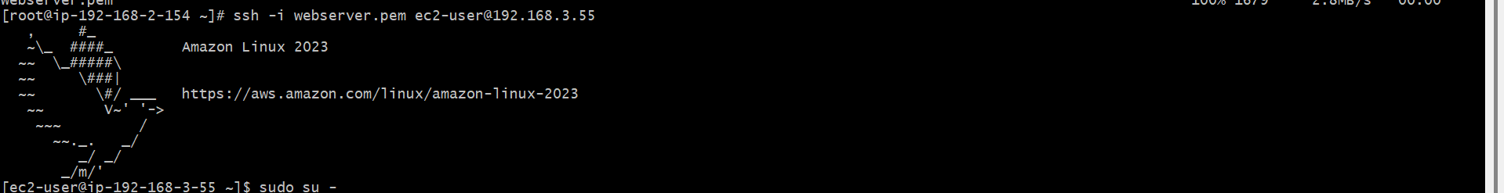
- By this command, u will login into that private instance successfully.
- To verify that internet access -> ping google.com
- It will show some results from the internet.

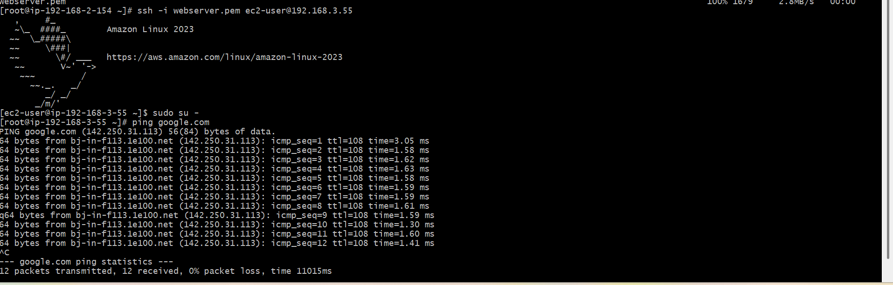

9. Install Apache Tomcat in private EC2 and deploy a sample app.

PURPOSE: To download apache tomcat in private EC2 with the help of public instance that is bastion server or jump server.

STEP BY STEP IMPLEMENTATION:
- First of all, login into bastion server that is public instance.
- From bastion server, login into private instance.
- Then in the private instance, download java 17 version by using command -> sudo yum install java-17
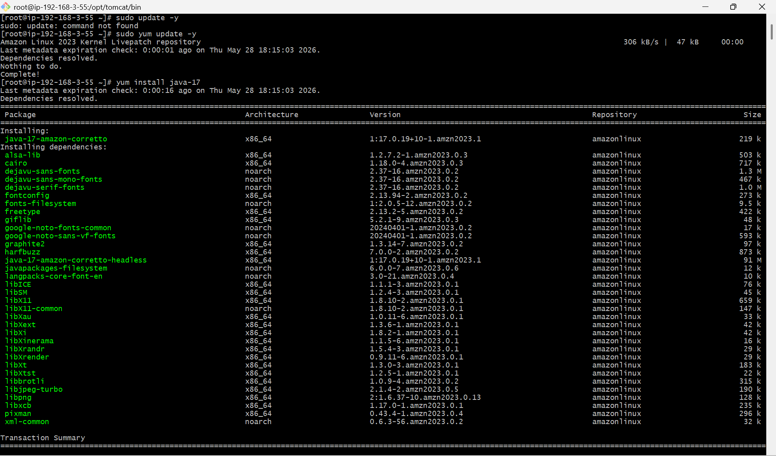
- Then after downloading java-17, download tar file from the browser by copying the link using wget command ->
Wget <tomcat 9 link>
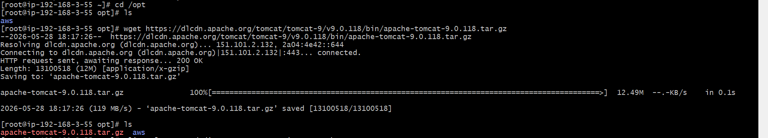
- Extract the tar file by using the tar -xvzf command into a new directory tomcat -> tar -xvzf apache-tomcat-9.0.118.tar.gz -C /opt/tomcat --strip-components=1
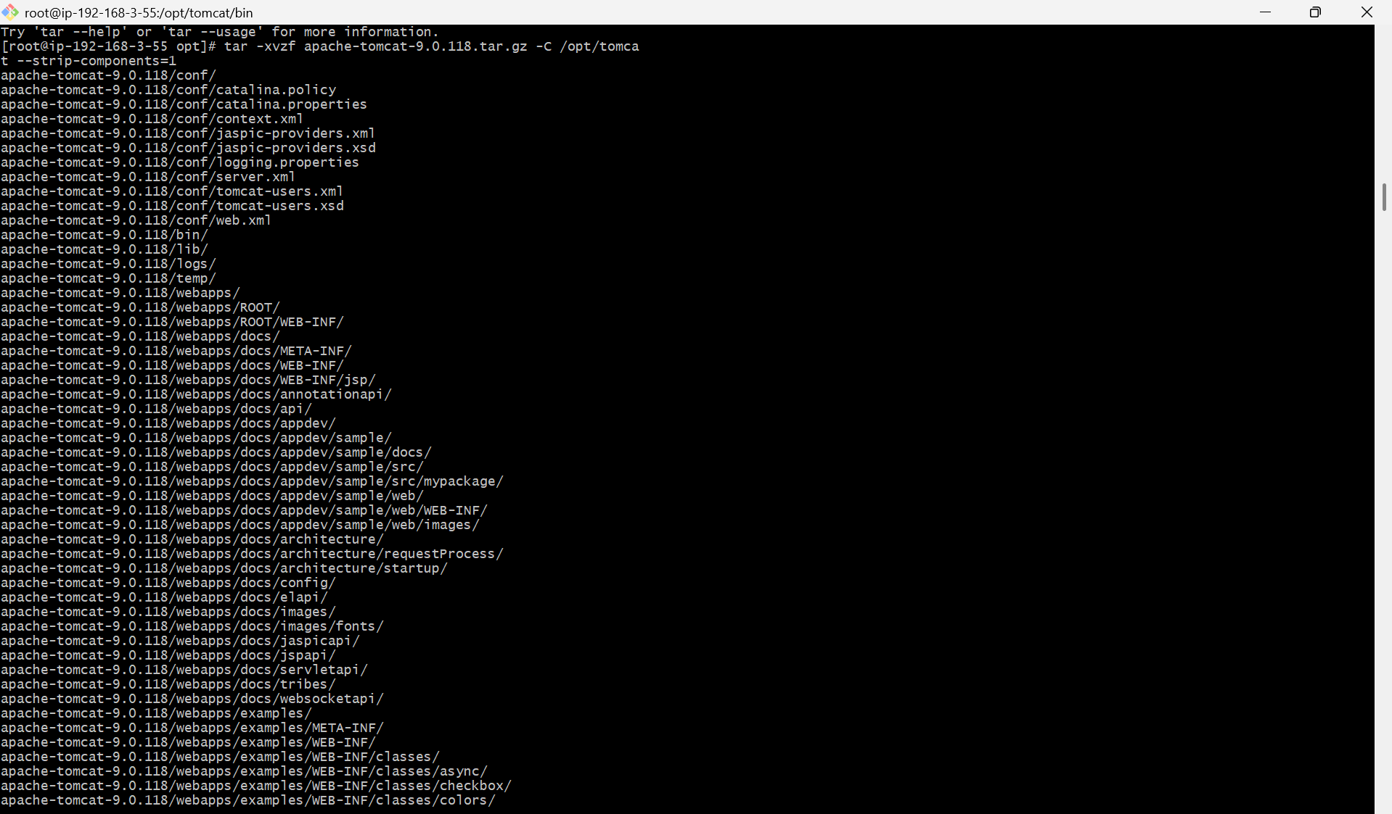

- Now execute the command ./startup.sh to start the tomcat service.
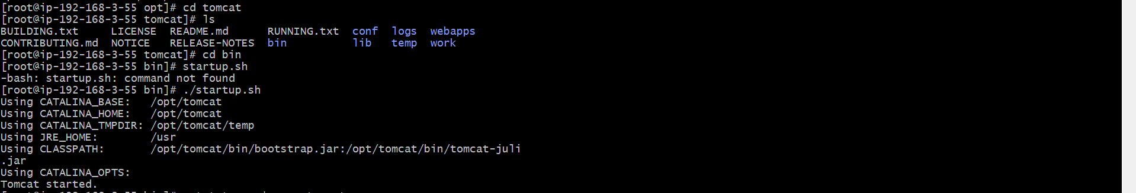

- I have installed tomcat in a private instance so we will not able to see the tomcat home page in the browser.
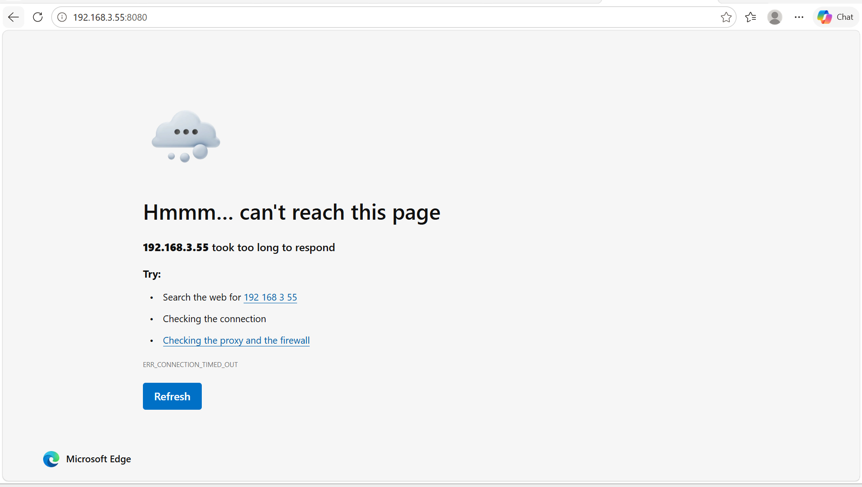

- if you see the html file when you execute the command netstat. Then tomcat service is successfully and running also.
- when you execute curl http://local-host:8080 then you will get to see some html file in the terminal.

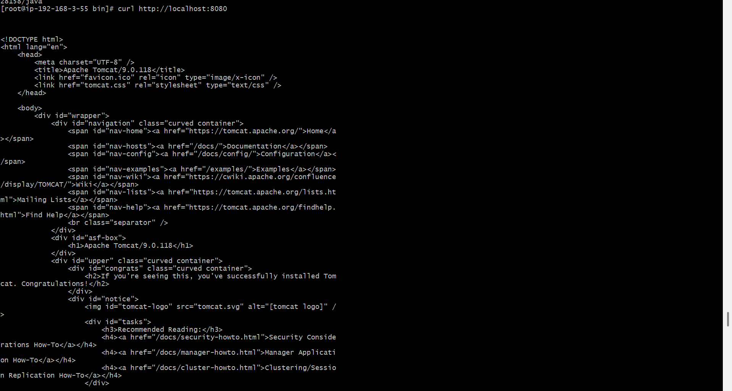

10. Configure VPC flow logs and store the logs in S3 and CloudWatch.

PURPOSE: Configuring VPC Flow Logs is essential for monitoring and managing network traffic within an AWS VPC. By capturing and logging IP traffic, you can gain insights into network performance, security, and compliance. The logs can be stored in S3 for long term retention. CloudWatch logs provides real-time visibility into network activity, allowing for quick troubleshooting and response to security incidents. Together, these logs serve as a comprehensive tool for network management and security auditing in AWS environments.

OBJECTIVE: The objectives of configuring VPC flow logs and storing them in S3 and CloudWatch include:
- Traffic Monitoring
- Security Auditing
- Compliance
- Data Analysis
- Cost Efficiency

OUTCOME: By this process, this will create a S3 bucket and CloudWatch of our VPC Flow Logs.

STEP BY STEP IMPLEMENTATION:
- In the search bar, search for S3 service.
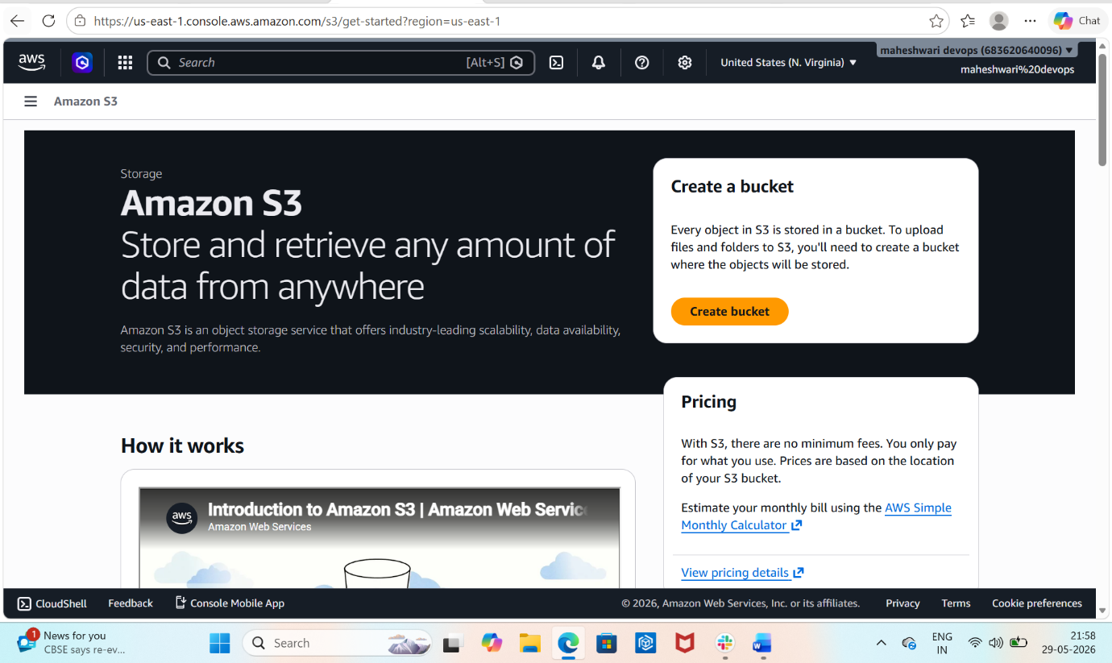

- Create a S3 bucket to store our flow logs of our VPC and name of the S3 bucket should be unique.
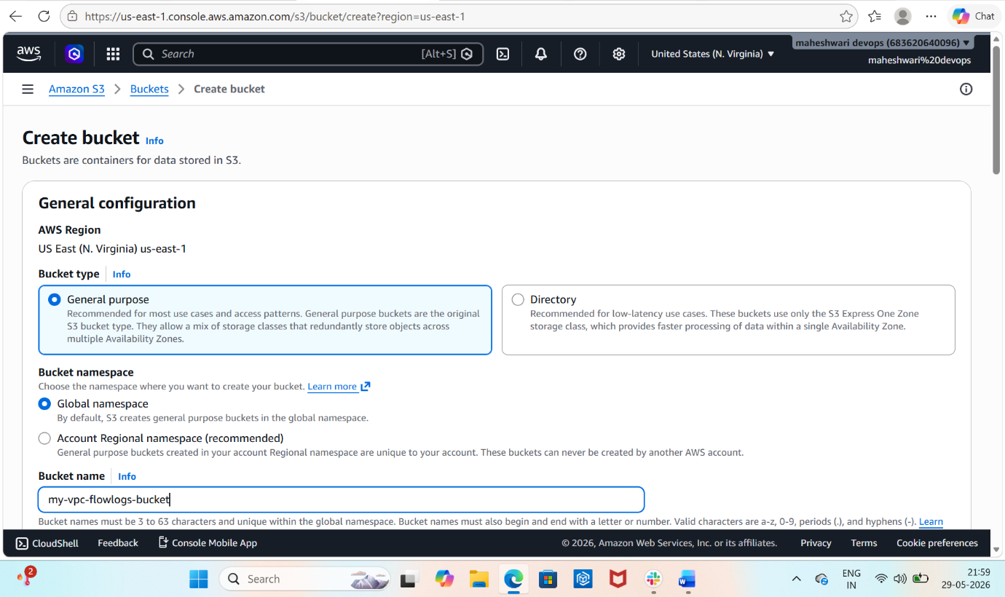
- Then click on create bucket.

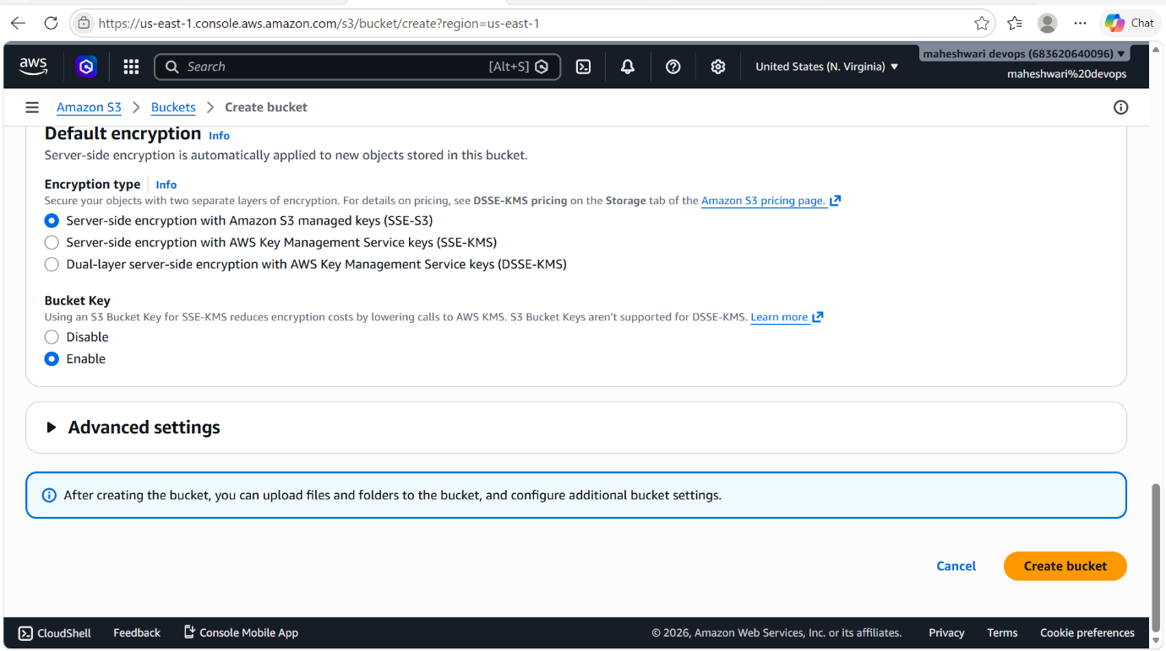

- Now S3 bucket is created.

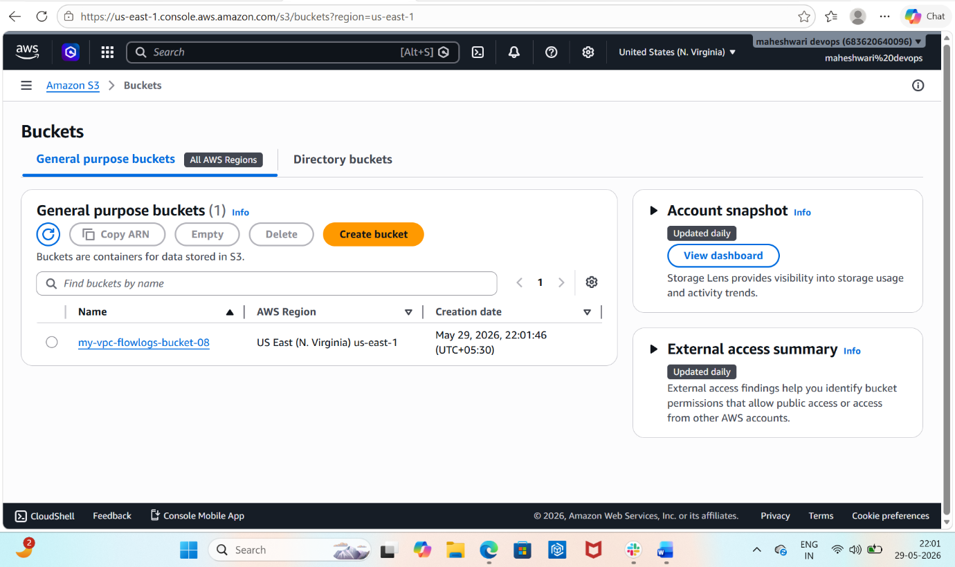

- To create a cloudwatch flow logs, go to our VPCdashboard and select on our VPC.
- Then go to flow logs path, now click on create flow log and it will drive to another page that to create a new flog log.
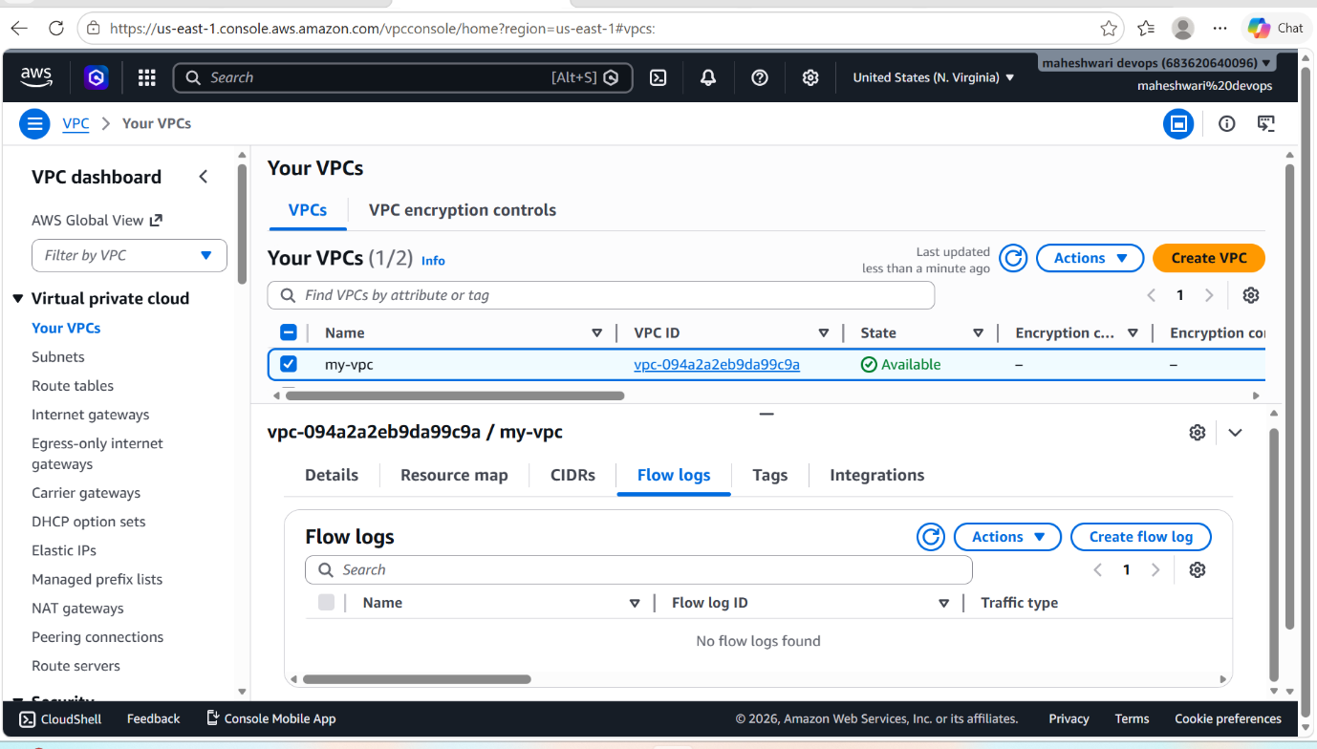
- Give the name to our flow log.

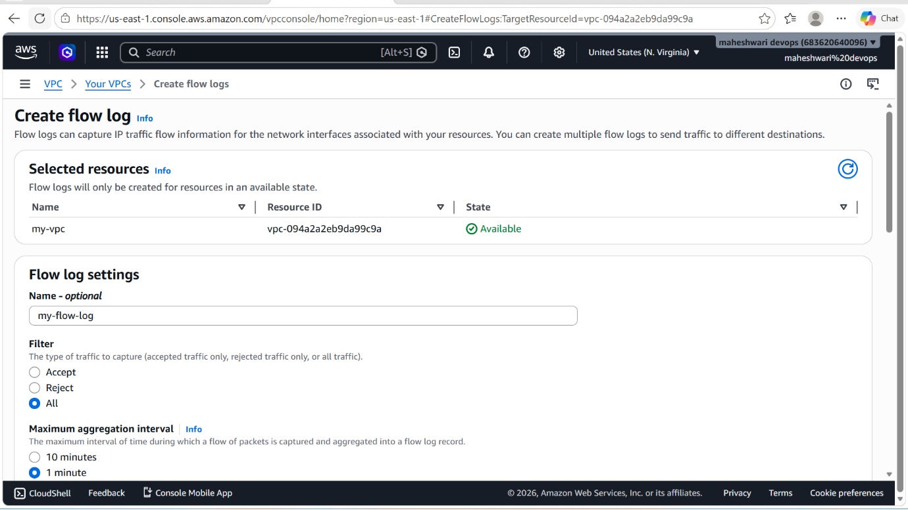

- Then when u scroll down it asks for the destination of flow logs, click on send to CloudWatch flow logs.
- Give a destination log group and it will help us to get the flow logs in the cloudwatch dashboard
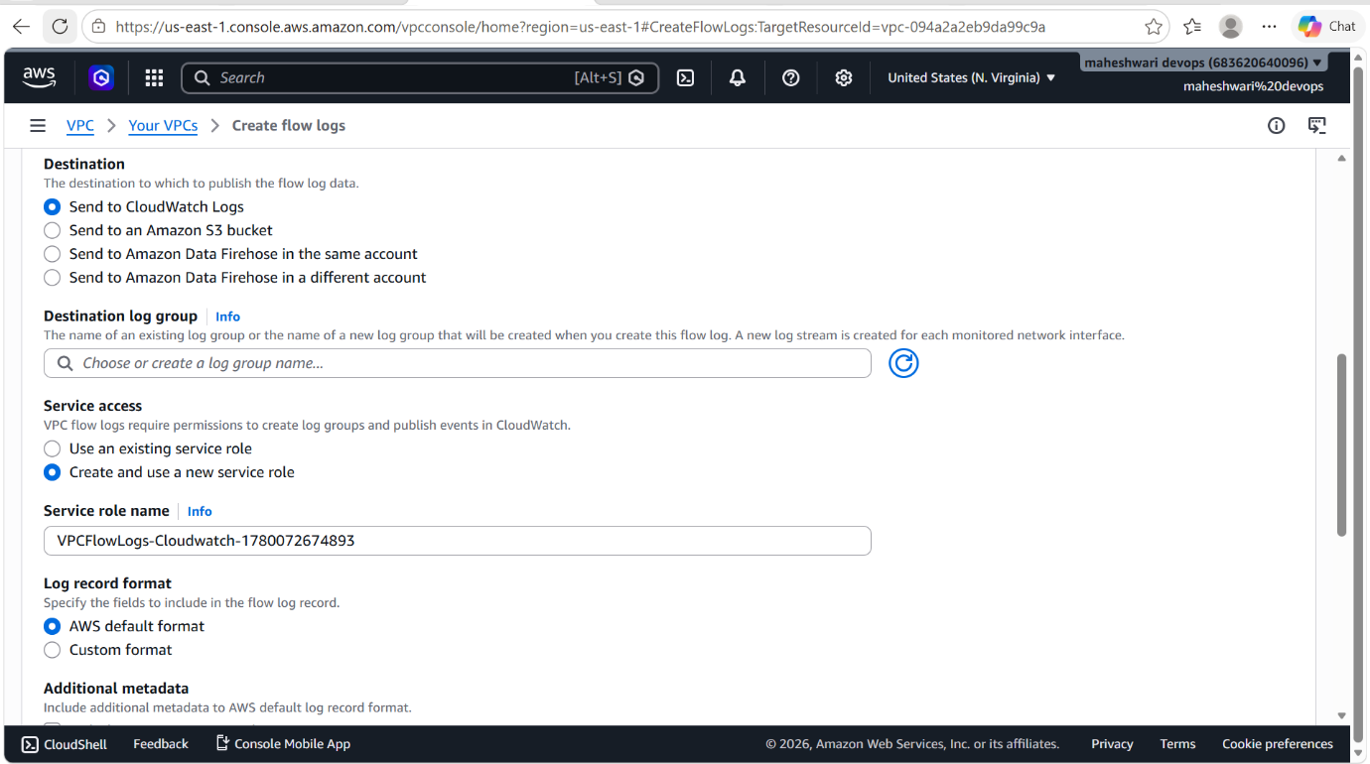
- Then click on create flow log and it will a flow log.

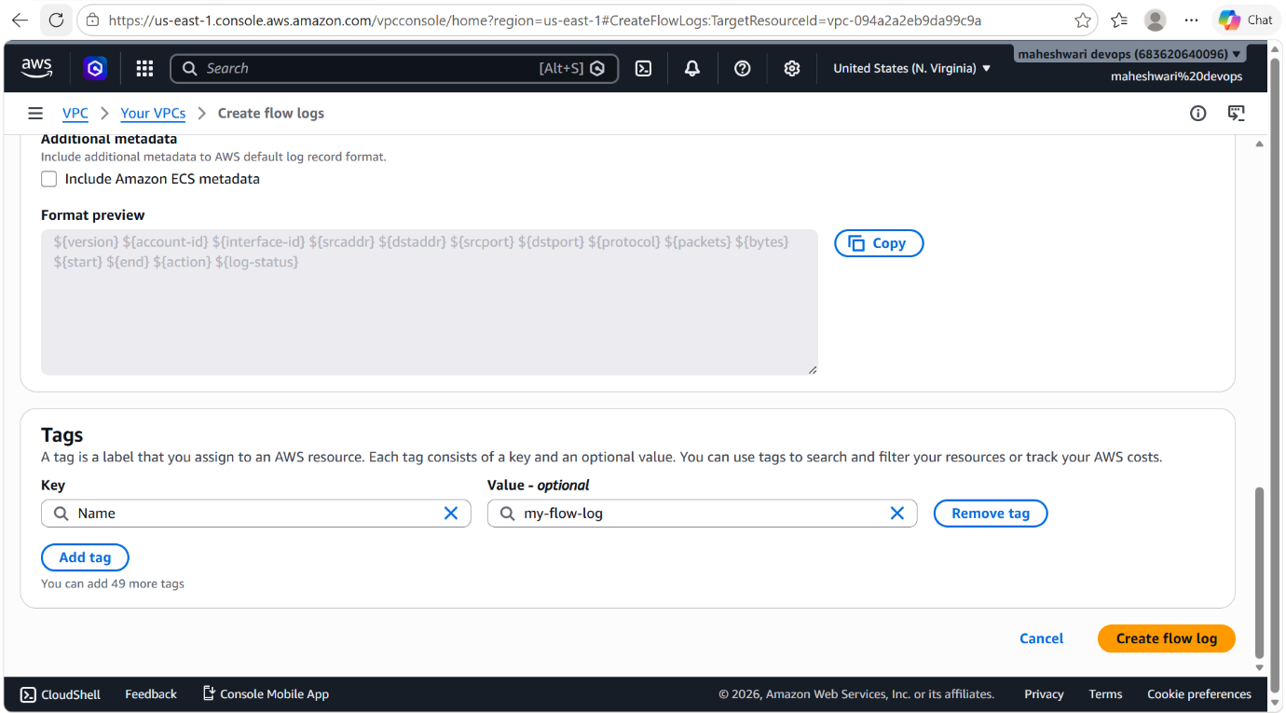

- Now to check these flow logs, go to CloudWatch service of AWS, there in the navigation pane click on logs and then log management, that’s where we can find flow logs of our VPC.

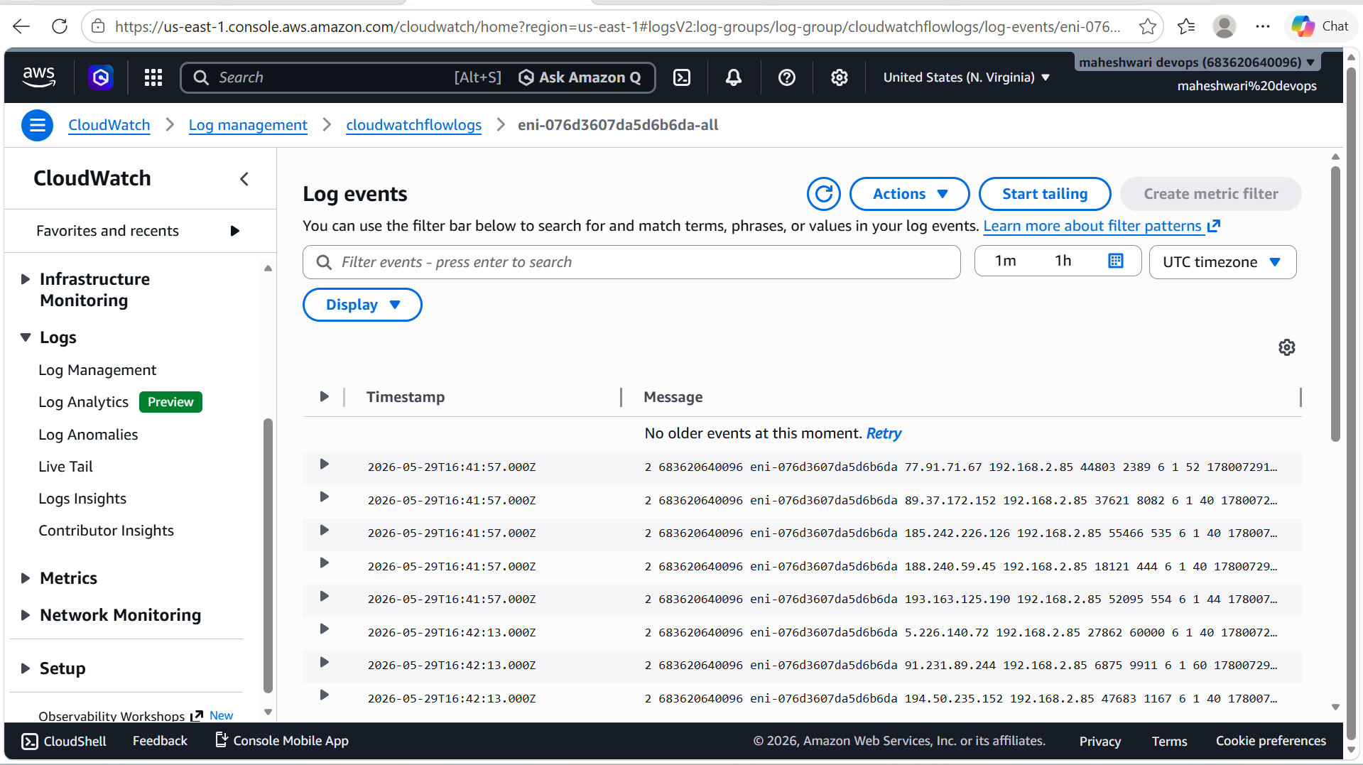

- To store our flow logs in S3 bucket, we have to follow same process that we have used for the CloudWatch flow log creation.
- The only difference is in the place of destination, we have to select send to amazon S3 bucket.
- And now it will ask for S3 bucket ARN.

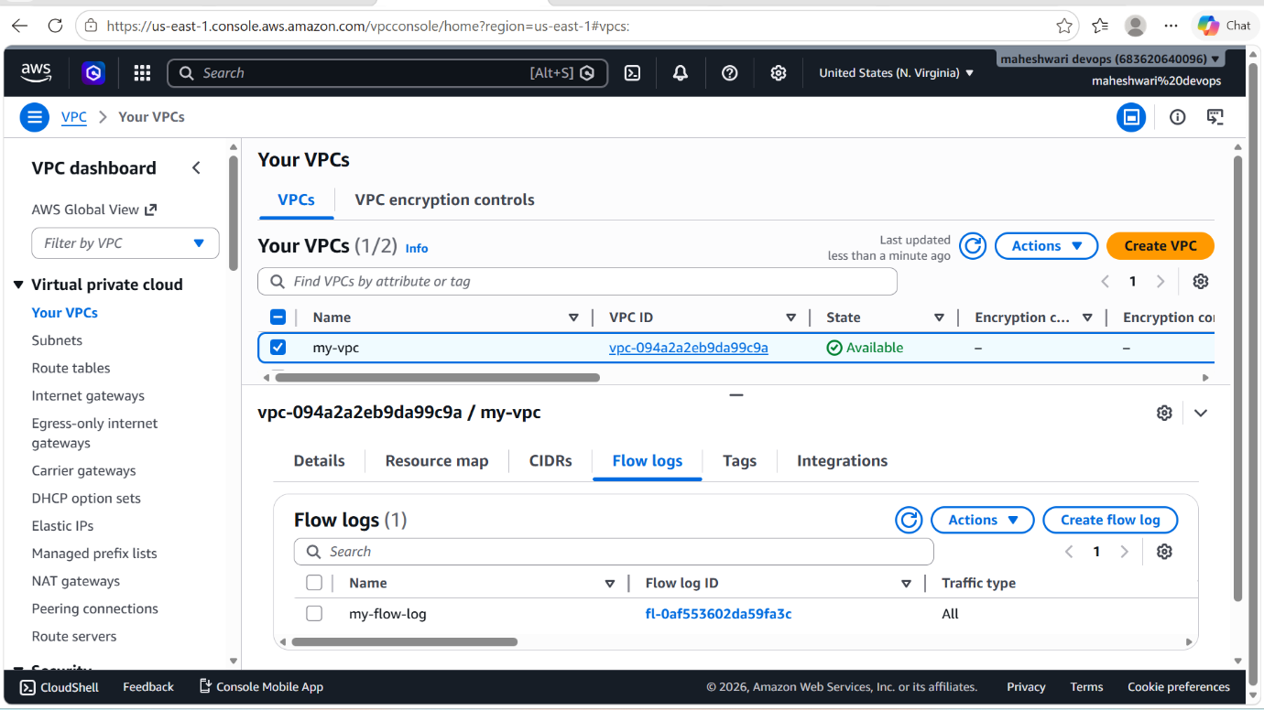

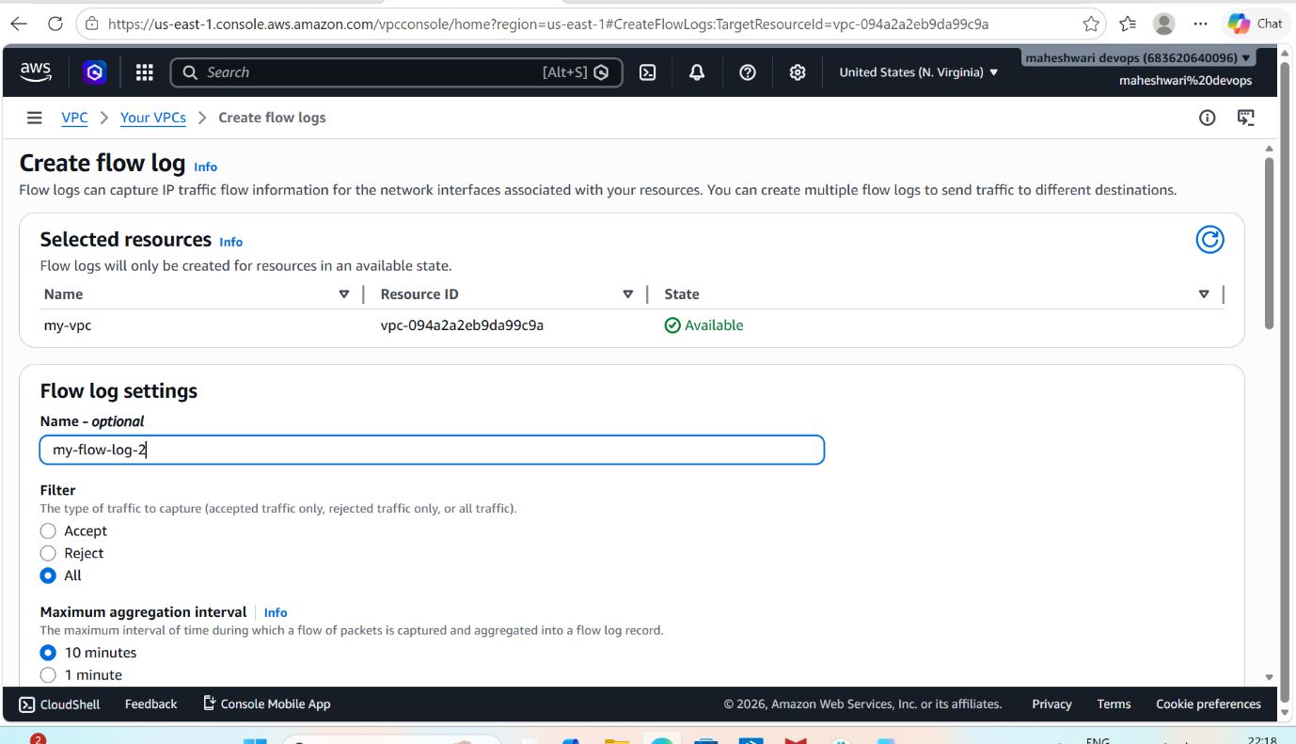

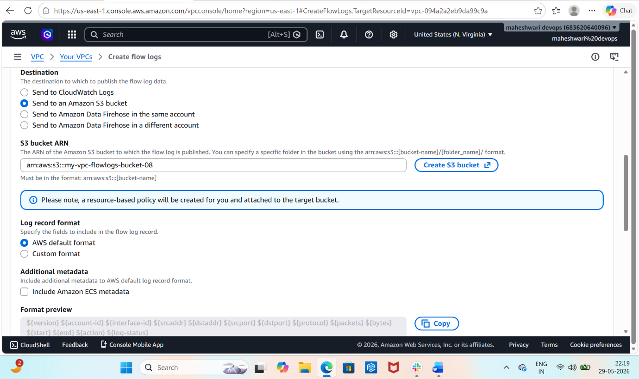

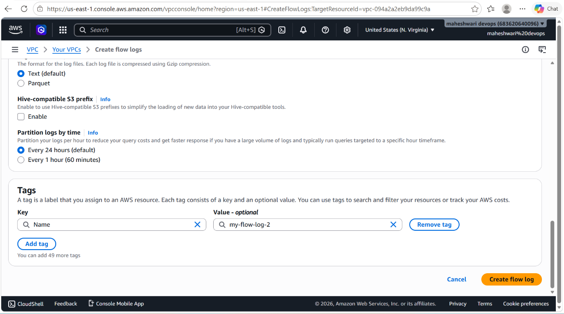

- Now to check our flow logs of VPC in S3 bucket, go to S3 service and click on the S3 bucket there u will get to see the flow logs of VPC and the file name will be AWSlogs/
- Then you are successfully created the flow logs in S3 bucket.

